Barriers faced by voice encouraging managers

Thesis submitted for the degree of
“Doctor of Philosophy”

By
Dorit Bitter

Submitted to the senate of the Hebrew University of Jerusalem
January, 2016

Barriers faced by voice encouraging managers

Thesis submitted for the degree of
“Doctor of Philosophy”

By
Dorit Bitter

Submitted to the senate of the Hebrew University of Jerusalem
January, 2016

This work was carried out under the supervision of:
Prof. Avraham N. Kluger

Acknowledgements

This dissertation was made possible thanks to the direction and support of many:
First and foremost I would like to thank my advisor, Prof. Avi Kluger for your guidance, support, hours of listening, and attention to detail. I could not have imagined having a better advisor and mentor for my Ph.D study.
I would also like to thank my committee members, Professor Linn Van Dyne, Professor Jeffery A. LePine and Professor Frances J. Milliken for your insightful comments, suggestions and invaluable feedback.
I sincerely appreciate the guidance of Prof. Lilach Sagiv, Prof. Tammar Zilber and Prof. Shaul Oreg for your guidance and direction in both theoretical and practical research tools.
Special thanks to my fellow PhD. colleagues and friends Dr, Dotan Castro, Guy Itzchakov, Andrey Elster, Tammy Rubel and Yaron Sela – your friendship, support and ideas made this research possible.
The real-life context of this research was prompted and made possible by my friends and colleagues at Amdocs, present and past. Thank you for your great support.
Deepest thanks and respects to my father, Prof. Michael Schieber that engrained the drive to constantly learn deep within me.
Last but not least, a huge and special thanks to my beloved husband Kobi and to my wonderful family for your boundless love, support and encouragement.

Abstract
Voice is defined as discretionary communication of ideas, suggestions, concerns, or opinions about work-related issues with the intent to improve organizational or unit functioning, and it has many documented benefits such as enhanced employee engagement, increased perception of fairness, and reduced employee attrition. Thus, to increase voice, it is important to understand its antecedents. Among the known antecedents of voice, is the degree to which the manager encourages it. In this work, I hypothesized, that voice-encouragement by managers is not sufficient and that additional variables interact with it to determine voice. Specifically, I hypothesize that when employees perceived that (a) voice is futile, (b) voice is risky, and (c) they are placed in a location distant from their manager, that voice will be low despite the voice encouragement of their manager. I also hypothesized that the above interactions will be further modified by individual differences, such as, level of employee performance, professional integrity, and propensity to trust. In addition, I explored the effects of voice topics (e.g., project related vs. colleague related) on voice, as well as its interactions with voice encouragement and individual differences.
To test my hypothesis, I ran six studies. Due to the complexity of these studies, I report them in separate chapters. Thus, in Chapter 1, I provide the overall theoretical review of my hypotheses. In Chapter 2, I provide an overview of the all the studies. In Chapter 3, I report the tests of all variables, save for those involving voice topics, and in Chapter 4 I report the results pertaining to voice topics.
In Chapter 3, I report the following findings. Across four studies, I found that voice encouragement indeed increases voice, consistent with past studies. I also found that perceived futility both directly reduced voice and moderated the above effect, such that, voice was highest when both futility was low and voice encouragement was high. This interaction was found both when I used an experimental design and when I used correlational design, supporting both internal and external validity of this hypothesis. Both perceived risk to the employee and physical distance were found to reduce voice but neither of these variables moderated the effect of the manager’s voice-encouraging behavior. Verbatim analysis suggested that professional-integrity may be a voice-enhancing variable that counteracts the effects of voice-reducing variables. In addition, I found a direct positive effect of individual-difference variables—(a) level of employee performance, (b) professional integrity, and (c) propensity to trust—on voice, but these variables did not interact with neither manager’s voice-encouraging behavior, nor with perceived-futility.
In Chapter 4, I report that work-related topics were found to be raised more frequently than personal and colleague-related topics. Additionally, voice topics interacted with manager’s voice-encouraging behavior, such that voice encouragement accentuated the difference between work-related topics and personal or colleague-related topics. I also raised two research questions in this chapter. The first research question was whether individual differences in performance, professional integrity, and propensity to trust moderate the effect of voice topic. I found that as performance and professional integrity increases, voice increases, especially for work-related topics, rather than personal or colleague-related topics, whereas as propensity to trust decreases, voice decreases, for personal or colleague-related topics, rather than for work-related topics, albeit the later finding was marginal.
The second research question was whether managers’ perceptions of the frequency of various voice topics mirror employees’ perception? And, what is the importance of various topics as perceived by managers? I found that managers perceive work-related topics to be voiced more frequently than personal or colleague-related topics. In addition, frequency and importance of voice interact with the individual difference of employee performance. Furthermore, the importance of almost all voice topics, with the exception of personal topics, is perceived to be higher than the frequency of which they are raised. And comparing employees and managers perception indicates that employees report voice significantly less frequently than the manager’s perception of their doing so.
In summary, in this research, I focused on the effects of voice-encouraging managers on employee voice, uncovered several boundary conditions that diminish the benefits of voice-encouragement by managers, and tested the impact of individual differences on voice. Overall, this research provides a greater level of granularity to understanding of the various forces at play when employees decide to voice, or not to voice, to their managers.

Table of Contents

CHAPTER 1 – Introduction and Theoretical Background 1
CHAPTER 2 – Overview of Studies 5
CHAPTER 3 – Voice-Attenuating Moderators 7
Perceived Futility 8
Perceived Risk 19
Physical Distance 30
Individual Differences 38
Chapter 3 Discussion 48
CHAPTER 4 – VOICE TOPICS 51
Voice-Attenuating Topics 54
Manager’s Perception 63
Chapter 4 Discussion 70
General Discussion 74
References 75
Appendix A – Scales and Measures 83
Appendix B – Verbatim Analysis Distribution Table 89

CHAPTER 1 - Introduction and Theoretical Background
This research is motivated by my personal experience as a manager, regarding my and other managers' attempts to encourage subordinates to voice their ideas, concerns and dilemmas. I observe that employee voice produces multiple organizational benefits, such as improved risk assessment, reduced fraud/deception, and providing critical information. This observation is consistent with theory, experimental works, and correlational studies. Theoretically, employee voice is postulated to reduce attrition (Hirschmann, 1970), increase perception of fairness (Lind & Tyler, 1988; Tyler & Lind, 1992) and enhance employee engagement and empowerment (Kotter, 1996; Luecke, 2003). Experimentally, employee voice was shown to increase perception of fairness (Folger 1977). Correlational studies show, for example, associations between employee voice and implementation success of new procedures (Edmondson, 2003).
Given the evidence for the importance of employee voice, the construct, the targets and the content of this concept need to be defined. The concept of voice was integrated by Morrison (2011) from various definitions (Burris, Detert, & Chiaburu, 2008; Detert & Burris, 2007; Dhetert & Trevino, 2010; LePine & Van Dyne,1998; Tangirala & Ramanujam, 2008; Van Dyne, Ang, & Botero, 2003; Van Dyne & LePine, 1998) as follows: “Discretionary communication of ideas, suggestions, concerns, or opinions about work-related issues with the intent to improve organizational or unit functioning.” (p. 375). This definition includes voice that is directed to one’s boss, other senior managers, and members of one’s team. However, the current research is focused on voice to one’s manager.
Content of voice varies: It can be about a way to improve a work-related problem (Van Dyne & LePine, 1998; Milliken, Morrison & Hewlin, 2003), an issue of significance (Dutton & Ashford, 1993), a situation of misconduct (Pinder & Harlos, 2001), or an opinion that differs from the views of others (Premeaux & Bedeian, 2003). That is, Morrison's definition captures the commonality among various conceptions of voice. In this work, I will show, among other things, that the various contents of voice impact the voice behavior itself. Yet, before considering voice content, I next review other variables that appear to affect voice.
One of the most important factors when an employee decides whether or not to voice is his or hers manager’s behavior. Both because the manager is the target of voice and because the manager has power over the outcome of voice, such as job assignments, performance evaluation and pay. For that reason, voice literature emphasized manager’s behavior with respect to voice. Voice is correlated with employees' perception that their supervisor is approachable and responsive (Saunders, Shepard, Knight, & Roth, 1992). Voice is also correlated with transformational leadership, presumably through employee encouragement and empowerment (Detert & Burris, 2007; Liu,Zhu, & Yang, 2010). In summary, voice-encouraging management seems to foster voice.
However, based on my experience, despite managerial encouragement often levels of voice remain low. Specifically, employees may hide information about organizational problems, not because of lack of supervisor listening and encouragement, but because of perceptions of risk ranging from fear of losing a job to fear of ruining good relationships with either supervisors or peers. In addition, employees refrain from speaking up when they believe that doing so will not make a difference. Indeed, employees avoid voice when they perceive that voicing is futile (Milliken, et al., 2003), when they lack experience or are in a low position in the organization (Milliken et al., 2003), when voice may imply a risky challenge to the status quo (Liu, Zhu, & Yang, 2010; Detert & Burris, 2007; Van Dyne & LePine, 1998) or when voice is implicitly perceived as risky to the employee (Detert & Edmondson, 2011). Thus, it seems the reasons for low voice can be summarized with Morrison and Milliken's (2000) suggestions that employees refrain from voice when they fear negative repercussions for speaking up (high risk) and when they believe that speaking up would not make a difference (low efficacy). In other words, voice may depend on its relative costs and benefits (Ashford, Rothbard, Piderit, & Dutton, 1998; Detert & Burris, 2007; Milliken et al.,2003).
In sum, among the classes of factors that affect voice are manager variables, such as voice-encouraging behavior, and employee variables such as, perceived risk, and futility. Yet, these variables are typically not researched in concert. Therefore, one goal of this study is to advance and test hypotheses about employee variables that act as moderators reducing voice even when the employee is encouraged to voice by his or her manager.
In chapter 3 of this research, I test the effect of the manager’s voice encouragement behavior on employee voice and suggest three moderators: perceived risk and felt futility based on Morrison and Milliken's (2000) classification of two causes of low voice: high risk and physical distance relying on Construal Level Theory (Trope & Liberman, 2010).
. In addition I test how individual differences relate to voice and interact with manager’s voice encouragement behavior and perceived futility. The individual differences variables tested in this model are mostly documented in the literature to relate to voice: employee performance (Detert & Burris, 2007), felt responsibility (Morrison & Phelps, 1999, Fuller et al., 2006), conscientiousness (LePine & VanDyne, 2001). Two additional individual-difference variables are hypothesized to relate to voice: authenticity at work (Van Den Bosch & Taris, 2013) and propensity to trust (Mayer, Davis & Schoorman, 1995, Colquitt et al., 2007).
In Chapter 4, I explore the effect of different voice topics on level of voice as perceived by employees and by managers (e.g., information about colleagues vs. questions about tasks). Furthermore, the individual differences described above are shown to interact with voice topics in predicting voice.
The overall theoretical model is depicted in Figure 1 and its components are elaborated in Chapter 3 and Chapter 4.
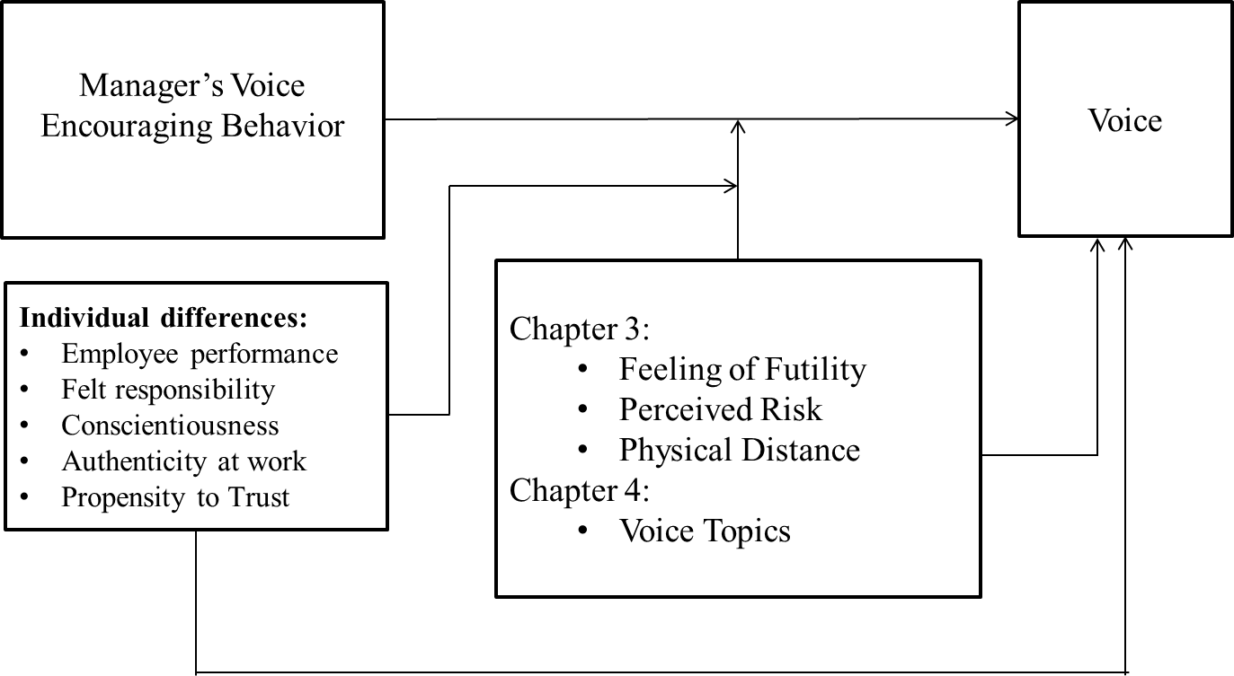
Figure 1. Theoretical Model

CHAPTER 2 – Overview of Studies
Six studies are reported in the current research. Study 1 pertains both to Chapter 3 and to Chapter 4. Studies 2-4 pertain to Chapter 3, and Study 5 and 6 pertain to Chapter 4.
Studies 1-4 test the effects of manager’s voice encouraging behavior on voice and the hypothesized moderating effects of felt futility (Study 1), perceived risk (Study 2 and 3) and physical distance from manager (Study 4). Finally, Study 1 also probed the effects of individual differences.
Studies 1, 5 and 6 investigated employee’s and manager’s perception of the effect of voice topic on voice, as well as manager’s perception of the importance of the various topics (Study 6)
The various studies employed different research designs and different samples. Specifically, Study 1 employed both a scenario experiment and correlational design on a large sample of working adults. Studies 2-4 were similar to Study 1, only that they were restricted to scenario experiments run on smaller samples. These are covered in Chapter 3.
In Chapter 4, I used a repeated measure design to explore the effects of voice topics on voice using data of Study 1, another sample of working employees (Study 5) and another sample of working managers (Study 6).
Furthermore, the respondents of Study 1 and 2 were Israeli adult employees, those of Study 3 and 6 were US based employees and managers, and the respondents of Study 4 and 5 were international employees and managers from different locations.

CHAPTER 3 – Voice-Attenuating Moderators
This chapter has three objectives: to replicate the benefits of manager’s voice-encouraging behavior on voice; to identify variables that may attenuate voice, even when voice is encouraged, including felt futility based on Milliken et al., 2003, perceived risk to the employee (Liu, Zhu, & Yang, 2010; Detert & Burris, 2007; Van Dyne & LePine, 1998, Detert & Edmondson, 2011) and physical distance between manager and employee (relying on Construal Level Theory (Trope & Liberman, 2010); and to explore the impact of individual differences on voice and their interaction with both manager’s voice encouraging behavior and felt futility. The individual differences tested in this model are employee performance (Detert & Burris, 2007), felt responsibility (Morrison & Phelps, 1999, Fuller et al., 2006), conscientiousness (LePine & VanDyne, 2001), authenticity at work (Van Den Bosch & Taris, 2013) and propensity to trust (Colquitt et al., 2007).
Voice-encouraging management seems to induce voice. Voice is correlated with employees' perception that their supervisor is approachable and responsive (Saunders, Shepard, Knight, & Roth, 1992). Voice is also correlated with transformational leadership, through employee encouragement and empowerment (Detert & Burris, 2007; Liu,Zhu, & Yang, 2010). Indeed, managerial encouragement was found to induce voice (Ashford et al., 1998, Detert & Burris, 2007, Miceli, Near, & Dworkin, 2008, Milliken et al., 2003, Saunders et al., 1992). I, therefore, hypothesize that:
H1: The perception of a voice encouraging manager induces voice.
However, I hypothesize that certain conditions may attenuate the benefits of manager’s voice-encouragement behavior. These conditions and variables will be discussed in the following section.
Voice-Attenuating Moderators

Perceived Futility
Employees avoid voice when employees feel that raising their concerns would not make a difference (Milliken et al., 2003), and when they perceive both (poor) approachability⎯the degree to which supervisors make the process of voicing more certain, and (low) responsiveness⎯the extent to which supervisors are perceived to be responsive to employee voice (Saunders et al., 1992). However, these variables were not studied in concert with managerial voice encouragement. I propose that managerial voice encouragement interacts with felt futility, such that managerial encouragement may matter less when futility is high. Specifically,
H2: Feelings of futility decrease voice.
H3: The beneficial effect of voice encouragement on voice is moderated by feelings of futility, such that perceived voice encouragement induces voice largely for employees that believe that voicing the topic would not be futile.
See Figure 2
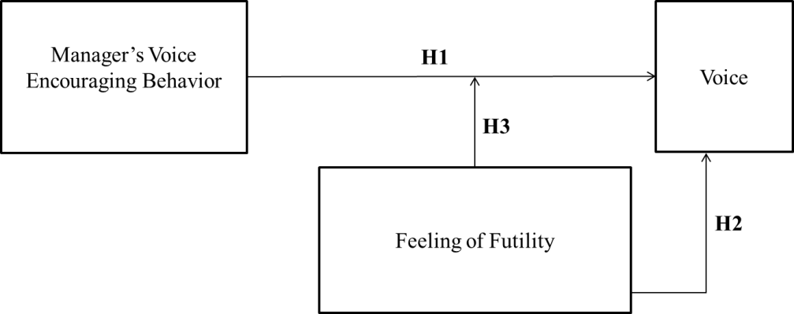
Figure 2. H1-H3 Theoretical Model.

The following experimental study tested these hypothesis.
Study 1 - Experiment and supporting correlational study
The Direct and Moderating Effect of Perceived Futility on Voice
Method
Participants.
Self-report questionnaires were distributed to 335 Israeli adult employees (51% male).
Measurements.
Manager’s Voice-Encouraging Behavior. To measure voice encouragement, I used ten items taken from the Facilitative Listening Scale FLS (Kluger & Bouskila-Yam, in press). The items were presented with anchors ranging from 0 = strongly disagree to 10 = strongly agree. The 10 items are presented in appendix A. Example items include: “When my current manager listens to me, most of the time s/he tries hard to understand what I am saying” and “ … , most of the time s/he pays close attention to what I say”. This measure had good reliability, α = .98.
Feeling of futility. I measured feeling of futility using 10 items, rated on an 11- point scale, ranging from 0 = strongly disagree to 10 = strongly agree, based on Saunders et al.’s (1992) voice-to-supervisor measure. Items are presented in appendix A. Example items include “My boss takes action to correct the concerns that I speak to him or her about” and “My boss is willing to support me if my concern is valid”; α = .90.
Voice-behavior was measured using items answered on an 11-point scale, ranging from 0 = almost never to 10 = almost always, based on Van Dyne and LePine’s (1998) prosocial-voice measure. Only the items pertaining to voice to the manager were used here. Items pertaining to both manager and peers were modified to pertain only to the manager. The five items used are presented in appendix A. Example items include: “I communicate my opinions about work issues to my manager even if my opinion is different and my manager disagrees with me” and “I speak up to my manager with ideas for new projects or changes in procedures”; α = .92.
Manipulation checks. The manipulation check were rated on a scale ranging from 0 = not at all to 10 = very much. Feeling of futility was measured with the item “To what extent do you think that raising this idea to your manager would be acted upon?” and Voice encouragement with “To what extent do you feel that your manager encourages you to speak and listens to you?”
Voice. I used the following items to measure the key dependent variable: “How likely are you to voice your work-related idea to your manager?”, “… to raise any work-related suggestions to your manager?” and “… not to mention your idea to your manager at all?” (reversed coded). The items were rated on a scale ranging from 0 = not at all to 100 = very likely; α = .89.Demographics. Age, Gender, Education, Country of Birth, Country of residence, Overall and Current-role years of experience, and work partiality.
Respondents were asked to answer additional measures that will be discussed in later sections of this chapter and in Chapter 4.
Procedure.
Respondents were asked to both respond to measures tapping their real-work experience and to respond to a hypothetical scenario. I randomized the order of reporting real-work experience either before (47%) or after (53%) the presentation of the scenario experiment. Furthermore, I randomized the order of responding to the specific scales tapping real-work experience.
Using scenarios, I manipulated, using a 3x2 experimental design, voice encouragement (low, neutral, high) and feeling of futility (high, low). (I coded these experimental conditions with -1, 0, 1, and -1, 1, respectively). Specifically, all participants read: “Please imagine the following situation that has the following key features:
1. You have a new work-related idea that may improve the success of your project while reducing costs and timelines.
2. (Low) Voice encouragement was described as: "Your manager usually (doesn’t) encourages you to speak and (doesn’t) listens to you." In the neutral condition, no information about voice encouragement was provided.
3. (High) feeling of futility / (Low) feeling of efficiacy - was manipulated with the following text: "the chances that your ideas and suggestions would be acted upon and implemented by your manager are extremely high (low). More than likely, your manager will (not) take your ideas and suggestions forward”
After reading the scenario, respondents filled out the manipulation checks, the voice measure, and demographic variables.
Analysis and Results
The manipulation checks indicated, as expected, that the voice-encouragement condition significantly affected the manipulation check of voice encouragement, r = .40, p < .001. Also, the voice-futility condition significantly affected the manipulation check of voice futility, r = .40 (sic), p < .001. Specifically, the voice encouragement was highest in the high condition, intermediate in the neutral condition, and lowest in the low condition. See Table 1.
Table 1
Ns, Means, SDs of manipulation checks by experimental conditions
Condition | N | M | SD
Voice Encouragement
Low | 102 | 4.1 | 3.16
Neutral | 110 | 6.1 | 3.26
High | 108 | 7.3 | 2.34
Low Futility (High Efficacy)
Low | 156 | 4.4 | 2.97
High | 164 | 6.8 | 2.53
Note. All means differ by p < .05To test my hypothesis, I ran two-way ANOVAs on the voice ratings (see Table 2 and Figure 3). Consistent with H1, the voice encouragement manipulation increased voice, F(2, 317) = 10.26, p < .001, η² = .062. Consistent with H2, the (low) futility manipulation increased voice, F(1, 317) = 35.8 p < .001, d = 0.65. Consistent with H3, the Voice encouragement x Felt Futility interaction was significant, F(2, 317) = 4.75, p = .009. An inspection of Figure 3, suggests that voice encouragement was effective largely when felt-futility was low. Therefore, I tested the one-way ANOVA effect of voice encouragements within each of the two futility conditions. As expected, voice encouragement did not affect voice in the high-futility (low-efficacy) condition, F(2, 154) = 1.53, p = .22, but increased voice in the low-futility (high-efficacy) condition, F(2, 161) = 16.06, p < .001 (for specific mean differences, see Table 2). Means and effect sizes can be found in Figure 3.
Table 2
Ns, Means, and SDs of Voice by Felt Futility and Perception of Voice Encouragement
 | Felt Futility (Efficacy)
 | Low (High) |  |  |  | High (Low)
Perception of Voice Encouragement | N | M | SD |  | N | M | SD
Low | 53 | 59.4ª | 24.8 |  | 48 | 53.5 | 26.1
Neutral | 56 | 81.9^{ab} | 17.0 |  | 53 | 55.9 | 25.7
High | 53 | 77.5^{b} | 23.0 |  | 54 | 61.9 | 24.0
Note: Means that do not share subscripts differ by p < .001

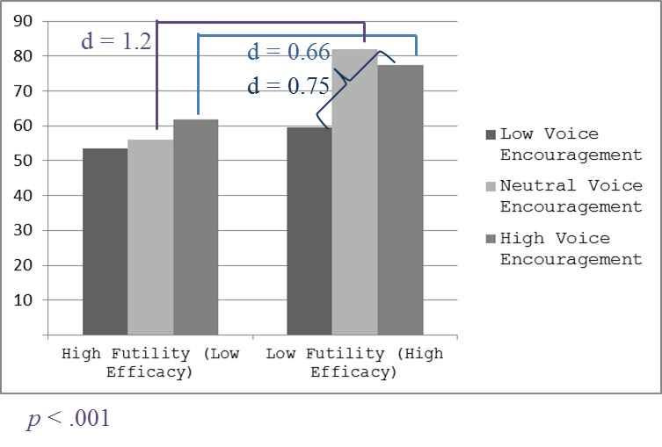
Figure 3. Voice by felt-futility and perception of voice-encouragement
Controlling for unexpected experimental effects.
As can be seen in the top of Table 3, the felt-futility condition affected, unexpectedly, the voice-encouragement-manipulation check, r = .27, and the voice-encouragement condition affected the felt-futility-manipulation check, r = .19. Therefore, I used multiple regressions to reanalyze my hypotheses, while controlling in each regression the irrelevant-manipulation check.
To predict the voice-encouragement-manipulation check, I entered to a regression both the felt-futility-manipulation check and the voice-encouragement condition. This regression was significant, F(2,317) = 276.0, p < .001, R² = .64, adjusted R²=.63. Although the felt-futility-manipulation check significantly predicted the voice-encouragement-manipulation check, β = .70, p <.001, the voice-encouragement condition remained a significant predictor of the voice-encouragement-manipulation check, β = .27, p < .001, suggesting this manipulation was successful.
Similarly, I entered to a regression both the voice-encouragement-manipulation check and the felt-futility condition. This regression was significant, F(2,317) = 244.20, p < .001, R² = .61, adjusted R²=.60. Although the voice-encouragement-manipulation check significantly predicted the felt-futility-manipulation check, β = .70 (sic), p <.001, the felt-futility condition remained a significant predictor of the felt-futility-manipulation check, β = .21, p < .001, suggesting this manipulation was successful as well.
Next, I checked whether felt-futility manipulation check and felt-futility condition predicted voice-encouragement manipulation check in a similar manner. I found that the prediction model was significant, F(2,317) = 206.72; p < .001, and accounted for approximately 56% of the variance of voice-encouragement manipulation check, R² = .57; adjusted R² = .56. Felt-futility manipulation check was found to significantly predict voice-encouragement manipulation check, β = .77, p < .001, but as expected, felt-futility condition did not significantly predict voice-encouragement manipulation check, β = -.04, p = .36.
In the same manner, I checked if voice-encouragement manipulation check and voice-encouragement condition predicted felt-futility manipulation check. I found that the prediction model was significant, F(2,317) = 219.27; p < .001, and accounted for 58% of the variance of felt-futility manipulation check, R² = .58; adjusted R²=.58. Voice-encouragement manipulation check was found to significantly predict felt-futility manipulation check, β = .81, p < .001. Although voice-encouragement condition was found to significantly predict felt-futility manipulation check, β = -.14, p < .001, the latter finding appears to be a spurious suppression effect, which nevertheless, does not threaten the integrity of the voice-encouragement manipulation. These findings in concert support the integrity of the experimental design.

Table 3.
Correlations among Experimental Variables, Real-Work-Experience variables and demographics.
 | M | SD | 1 | 2 | 3 | 4 | 5 |  | 6 | 7 | 8 |  | 9 | 10 | 11 | 12 | 13
Experimental variables
1. Voice encouragement condition | .01 | .8 | -
2. Voice encouragement manipulation | 5.8 | 3.2 | .44 | -
3. Efficacy condition | .01 | 1.0 | -.04 | .26 | -
4. Efficacy manipulation | 5.6 | 3.0 | .21 | .77 | .41 | -
5. Voice | 65.4 | 25.8 | .25 | .70 | .32 | .71 | -
Real-work-experience variables
6. Manager-facilitative listening | 7.2 | 2.5 | .07 | .38 | .00 | .34 | .35 |  | -
7. (Low) Futility | 7.1 | 2.2 | .11 | .42 | .11 | .39 | .40 |  | .56 | -
8. Voice behavior scale | 6.7 | 2.3 | .09 | .30 | .00 | .26 | .35 |  | .51 | .42 | -
Demographics
9. Gender | 1.5 | .5 | -.04 | -.03 | .00 | -.03 | -.02 |  | .11 | .09 | .07 |  | -
10. Education | 7.6 | 2.3 | -.06 | .00 | .00 | .05 | .02 |  | .04 | .04 | .06 |  | .15 | -
11. Age | 35.5 | 11.9 | -.09 | .04 | -.07 | .03 | .11 |  | .10 | .02 | .22 |  | .01 | -.01 | -
12. Years of work experience | 11.5 | 10.7 | -.03 | .05 | -.09 | .00 | .07 |  | .08 | -.03 | .19 |  | .01 | -.02 | .79 | -
13. Years at current role | 6.2 | 7.8 | -.05 | .04 | -.08 | .00 | .04 |  | .07 | -.06 | .11 |  | -.01 | -.05 | .54 | .74 | -
14. Part-time (1 = part; 2 = full) | 1.9 | .3 | .03 | -.05 | -.03 | .00 | .01 |  | .03 | .07 | .14 |  | .03 | -.03 | .12 | .11 | .09
Note. 300 <= N <=330.
When r’s > |.12| p < .05 (two-tailed).

Controlling for order of presentation.
As detailed in the Method, I randomly assigned the order of taking the correlational measures either before (47%) or after (53%) the presentation of the scenario experiment. Therefore, I wanted to ascertain that the experimental results were not confounded with order of presentation. Thus, I ran a three-way ANOVA on the voice ratings (see Table 4). The analysis yielded neither a significant-main effect of order nor any two-way, or a three-way interactions. This analysis lends further credibility to the experimental results.
Table 4
Voice-encouragement, Felt-futility and Order-of-questions Main Effects and Interaction
 | Df | F | p
Voice-encouragement (A) | 2,317 | 9.56 | .00
Felt-futility (B) | 1,317 | 33.49 | .00
Order-of-questions (C) | 2,317 | 2.12 | .15
A x B | 2,317 | 4.98 | .007
B x C | 1,317 | 1.88 | .17
A x C | 2,317 | 0.22 | .80
A x B x C | 2,317 | 1.42 | .24

Tests of hypotheses with real-work-experience variables (correlational design).
Next, I retested my hypotheses using the correlational design with the variables that were measured regarding real-work experience. The correlations among the experimental and the real-work-experience variables are presented in Table 3. As can be expected, the voice reported in the experiment was positively correlated with the voice reported at work and with the manipulation checks, and all at-work measures were positively correlated, lending converging validity to both H1, and H2.
To test H3, I regressed real-work voice on the demographics, manager-facilitative-listening, futility, and their interaction, where real-work manager-facilitative-listening and futility were centered about their means. The presence of the demographics did not affect the conclusion. Therefore, below I report the result of the test of H3 without the demographic variables. The regression was significant, F(3,302) = 46.7, p < .001, R² = .32, adjusted R² = .31. As expected, voice was related to manager-facilitative-listening, β = .51, p < .001, futility, β = .15, p = .01, and their interaction, β = .19, p = .001. To probe the direction of the interaction, I plotted (see Figure 4) the predicted the simple slopes of manager-facilitative-listening from one SD below to one SD above the mean, separately for futility one SD below the mean and one SD above the mean.

Figure 4. Two-way interaction of real-work work manager-facilitative-listening and futility on real-work voice behavior.
Discussion
In Study 1, both the experimental data and the correlational data support my hypotheses, and suggest that manager’s voice-encouragement increases voice (H1), felt-futility by the employee reduces voice (H2), and that felt futility attenuates the benefit of manager’s voice-encouragement (H3). The findings regarding H1 and H2 replicate findings reported in the literature (e.g. Saunders, et al., 1992 and Milliken, et al., 2003). The support for H3 adds to the understanding of the complexity of voice. Indeed, there are additional variables that are known to affect voice, to which I turn next.

Perceived Risk
Milliken et al. (2003) have found that the most frequent reason for remaining silent was fear of being viewed negatively, and as a consequence, damaging relationships, followed by fear of retaliation. Similarly, lack of voice—conceptualized as silence—was linked with concerns about negative repercussions of speaking up (Morrison & Milliken, 2000). Indeed, experiments suggest that employees who engage in more challenging forms of voice were viewed by their managers as poor performers and as having ideas that are not likely be endorsed (Burris, 2012). To summarize, risk is negatively linked with voice.
Yet, managerial-voice encouragement and risk were studied separately, while they may interact, such that managerial encouragement may matter most when risk is low. Specifically,
H4: Perceived risk to the employee decreases voice.
H5: The positive effect of the perception of a voice-encouraging manager on voice is moderated by perceived risk, such that the perception of a voice encouraging manager produces high voice, especially when the perceived risk is low.
See Figure 5
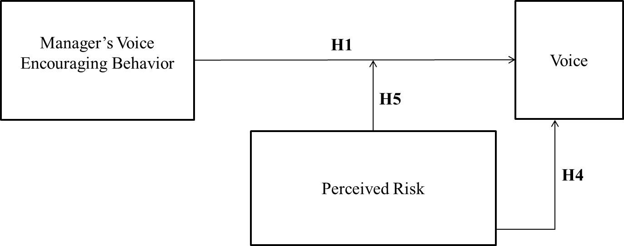
Figure 5. H1, H4 and H5 Theoretical Model.
Studies 2 and 3 test these hypotheses.
Study 2 - Experiment
The Moderating Effect of Perceived Risk on Voice
Method
Participants.
Web-surveys were distributed to N = 156 Israeli adult employees (72 male).
Procedure.
Participants were presented with a scenario and asked to fill out a short survey in Hebrew. Each participant was presented with one scenario out of four. The scenarios reflected a 2x2 experimental manipulation of Voice-encouraging manager (low vs. high) X Perceived risk (high vs. neutral).
(No) Perception of a Voice-encouraging manager was described as: "Your manager is usually (not) approachable to you and (not) responsive to your needs and requests. You feel that your manager (doesn’t) understand(s) you. Your previous experience of talking to your manager was (not) positive."
Perceived risk was described as:
While working on a work related project you are not sure at some point about the best way to proceed. Progressing in the wrong direction may lead the project to failure or result in timeline or financial losses. (However, raising this concern to your manager may threaten your position or raise doubts regarding your professional capabilities).
In the neutral condition, no information about risk to the employee was provided.
Measures.
Voice. “Would you share your dilemma with your manager?”, 0 = not at all and 10 = very much. Voice was negatively skewed and thus was transformed by squaring the original scores to normalize the distribution.
Open question. I asked respondents to answer the following open-ended question: “Please share the reasons for your answer.” I asked two coders to rate the answers to this question by identifying motives for voice (or lack thereof). Disagreements were resolved by discussion. When motives emerged from the text, the coder rated the presence of each motive with either 0 = motive was not apparent in the statement or 1 = motive was apparent in the statement.
Demographics. Age, gender, and years of experience.
Analysis and Results
A two-way ANOVA was conducted on the voice ratings. Results are presented in Tables 5 and 6 and Figure 6. The analysis yielded a significant main effect of perception of voice-encouraging manager, F(1, 157) = 30.1, p < .001, d = 0.84 indicating that voice ratings were significantly higher when participants were encouraged to voice, supporting H1. The main effect of perceived risk was not significant, F(1, 157) = 0.97, p = .33, d = 0.16. Furthermore, the perception of voice-encouragement x perceived risk interaction was also not significant, F(1, 157) = 1.65, p = .20, d = 0.20.
Table 5
Ns, Means, SDs of Voice by Perceived Risk and Perception of Voice Encouragement
 | Perceived Risk
 | Low |  |  |  | Neutral
Perception of Voice Encouragement | N | M | SD |  | N | M | SD
Low | 37 | 64.68 | 39.39 |  | 37 | 63.08 | 39.24
High | 49 | 86.71 | 25.36 |  | 34 | 98.61 | 24.58
Note. Voice was negatively skewed and thus was transformed by squaring the original scores to normalize the distribution

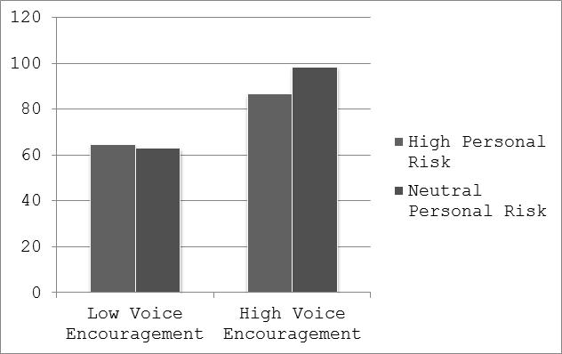
Figure 6. Means of voice (squared) by voice encouragement and perceived risk.

Although the interaction was not significant, I ran independent-samples t-tests to compare level of voice in high and neutral risk conditions, because I had an a priori hypothesis.
In the low voice-encouragement condition, there was no significant difference in the level of voice in the high-risk condition, M = 64.7, SD = 39.4, versus the neutral-risk condition, M = 63.1, SD = 39.2, t (72) = 0.10, p = .86, d = 0.04. However, in the high voice-encouragement condition, the high-risk condition reduced voice, M = 86.4, SD = 25.6, relative to the neutral-risk condition, M = 98.6, SD = 24.6, t (80) = -2.16, p < .05, d = -0.49. This finding is consistent with H5.
Verbatim answers analysis.
The two coders identified three main motives in the answers to “Please share the reasons for your answer.” These were Integrity – statements regarding the professional integrity of the employee, for example, “I would raise my concern because of the importance of the success of the project,” or “I would not let the project fail” (mentioned by 39% of the participants); relationship – statements regarding the relationship with the manager, for example, “I would voice my concern because my manager is responsive and positive” (31%); and Sharing – statements regarding the need to share the concerns with others, for example, “I would share my concern because I need to share the risk with others.” (28%). Please see Appendix B for the full motive-distribution count and distribution table.
Next, I tested whether the experimental conditions (voice-encouraging manager and risk) affected the frequency in which each of the above motives emerged in the text. To test these effects, I tabulated each motive (present or not), by Voice-encouraging manager X Risk, and inspected both the χ²’s for the entire table, and then the χ²’s for motive by risk, for each of the two voice-encouraging-manager conditions, separately. The χ²₍₁₎’s were 3.14, p = .08, for integrity, 6.40, p = .04, for relationships, and 0.07, p = .79, for sharing. Given the values of these tests, I further explored the effects within cells for integrity and relationships.
For integrity, I found that when the voice-encouragement was low, there was no difference in the frequency of this motive between the neutral and high risk condition, χ²₍₁₎ = 0.11, p = .74. In contrast, when the voice-encouragement was high, the frequency of integrity was mentioned much more frequently when risk was high (53%) than when risk was neutral (23%), χ²₍₁₎ = 7.24, p = .01, φ = -.29.
For relationships, I found that when the voice-encouragement was low, there was no difference in the frequency of relationships between the neutral and high risk condition, χ²₍₁₎ = 0.11 (sic), p = .74 (sic). In contrast, when the voice-encouragement was high, the frequency of relationships was mentioned much more frequently when risk was neutral (44%) than when risk was high (18%), χ²₍₁₎ = 6.48, p = .01, φ = .28.
These interactions are consistent with H5, in that, the effects of voice-encouraging behavior are moderated by risk. Yet, the DVs here are not voice, but, more likely considerations people make in deciding whether to voice or not. This in turn suggests that individual differences in these motives will further moderate the effects of voice-encouraging behavior. For example, people high integrity may voice even in the face of risk, if their manager encourages voice. Therefore, I will explore this possibility later (below).
Study 2 has three limitations. First, the voice-encouraging condition contrasted low levels with high levels of encouragement. This prevents learning whether high levels of encouragement increases voice, or low levels of encouragement decreases voice, or both. Therefore, in Study 3, I added a middle condition, where I did not mention the voice-encouragement behavior. Second, the risk condition, contrasted neutral- with high-risk levels. Yet, employees may need to assess with some certainty that risk is low before they voice. Thus, in Study 3 I swapped the neutral condition with a low-risk condition. Although, it would be ideal to have 3-levels of risk as well, power consideration precluded this option. Finally, in Study 2 I measured voice with a single item. Therefore, in Study 3, I used a multi-item scale to measure voice. My goals in Study 3 were to replicate the results of Study 2 while overcoming the above limitations.
Study 3 - Experiment
The Direct and Moderating Effect of Perceived Risk on Voice
Method
Participants.
Self-report questionnaires were distributed to N = 60 US-based adult employees (60% male).
Procedure.
Using scenarios, I manipulated, using a 3x2 experimental design, voice encouragement (low, neutral, high) and perceived risk (high, low). Specifically, all participants read:
Please imagine the following situation that has the following key features:
1. You have a new work-related idea that may improve the success of your project while reducing costs and timelines.
2. [(Low) Voice encouragement] Your manager usually (doesn’t) encourages you to speak and (doesn’t) listens to you. [In the neutral condition, no information about voice encouragement was provided].
3. [(Low) Perceived risk] Raising this new idea to your manager may not be safe for you: it may threaten your position. There is some chance that voicing your suggestion would raise doubts regarding your professional capabilities. (Raising this new idea to your manager is safe for you: it will not threaten your position. Voicing your suggestion would not raise doubts regarding your professional capabilities.)
I coded the low/neutral/high levels of voice-encouragement condition with (-1), 0, and 1, respectively, and the low/high levels of the perceived-risk condition with (-1), and 1, respectively.
After reading the scenario, respondents filled out the manipulation checks, the DVs, and demographic variables.
Measurements.
Manipulation checks. Perceived risk was measured with one item “To what extent do you think that raising this idea to your manager is safe for you?” 0 = not at all and 10 = very much; Voice encouragement: “To what extent (degree) do you feel your manager encourages you to speak and listens to you?” 0 = not at all and 10 = very much.
Voice. I used the following items to measure the key dependent variable: “How likely are you to voice your work-related idea to your manager?”, “How likely are you to raise any work-related suggestions to your manager?” and “How likely are you not to mention your idea to your manager at all?” from 0 = not at all to 10 = very likely, α = .90
Demographics: Age, gender, country of birth, country of residence, overall and current-role years of experience, work partiality and having a manager (yes/no).
Results
The manipulation checks indicated, as expected, that both the voice-encouragement condition significantly affected the manipulation check of voice encouragement, r = .78, p < .001, and the perceived-risk condition significantly affected the manipulation check of perceived risk, r = .81, p < .001. Specifically, the voice encouragement was highest in the high condition, intermediate in the neutral condition, and lowest in the low condition. Similarly, risk was perceived higher in the high-risk condition and lowest in the low condition. See Table 6. Thus, the manipulations were successful.
Table 6
Manipulation Checks by Experimental Conditions
Voice Encouragement | N | M | SD
Low | 20 | 2.30 | 2.25
Neutral | 19 | 7.16 | 2.81
High | 21 | 9.52 | 2.11
Perceived Risk
High | 29 | 4.48 | 2.32
Low | 31 | 10.03 | 1.72
Note. The manipulation check of risk asked about safety, and thus under low risk the means are higher.
To test my hypotheses, I ran a two-way ANOVA on the voice ratings (see in Table 7 and Figure 7). The analysis yielded a significant main effect of voice encouragement on voice, F(2, 60) = 12.92, p < .001, η² = .324, supporting H1. Additionally, voice was higher when perceived risk was low, as opposed to high, F(1, 60) = 35.27 p < .001, η² = .395, supporting H4. However, the Voice encouragement X Perceived risk interaction was not significant, F(2, 60) = .11, p = .89, η² = .004. Therefore H5 is not supported.
Table 7
Voice by Perceived Risk and Perception of Voice Encouragement
 | Risk
 | High |  |  |  | Low
Voice Encouragement | N | M | SD |  | N | M | SD
Low | 10 | 3.23 | 1.93 |  | 10 | 6.6 | 2.07
Neutral | 8 | 5.83 | 2.41 |  | 11 | 8.67 | 1.91
High | 11 | 6.42 | 2.41 |  | 10 | 9.8 | 1.63

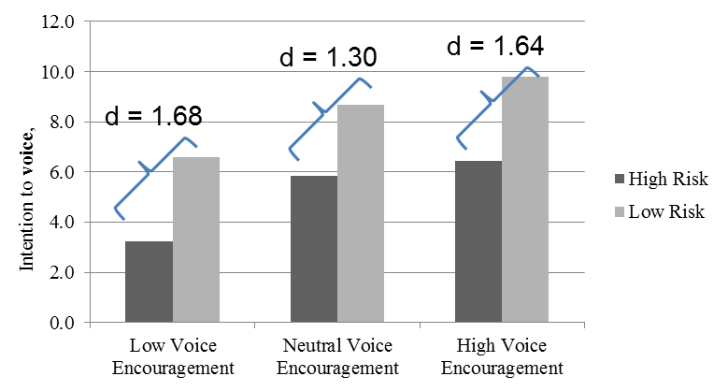
Figure 7. Voice by Perceived Risk and Perception of Voice Encouragement
Discussion
In both Study 2 and Study 3 H1 was supported, that is, voice increases when voice-encouragement is high. Study 3 also indicates that perceived risk to the employee reduces voice as hypothesized in H4. However, H5 is only partially supported in Study 2 and not supported in Study 3. Therefore, the moderating effect of perceived risk on voice-encouragement is not supported. However, in my analysis of the verbatim response, voice-encouraging behavior and risk interacted in affecting the frequency in which the motives of relationships and integrity emerges. This may suggest that the co-presence of voice-encouragement and risk does have a unique effect on considerations leading to voice, but that individual differences, such as in concerns for integrity, may further moderate the two-way interaction effect on actual voice. Next, after considering the effects of futility and risk on voice, I turn to the effects of physical distance.

Physical Distance
Modern organizations, often involve management that spans continents. Distance may impede voice. To probe the effects of distance, I rely on Construal Level Theory (CLT). According to CLT (Trope & Liberman, 2010),
Psychological distance is egocentric: Its reference point is the self in the here and now, and the different ways in which an object might be removed from that point — in time, in space, in social distance, and in hypotheticality — constitute different distance dimensions. Transcending the self in the here and now entails mental construal, and the farther removed an object is from direct experience, the higher (more abstract) the level of construal of that object. (p. 440)
Some experiments testing CLT (Stephan, Liberman, & Trope, 2010) are relevant to my question showing that the effect of construal level on resource allocation is such that participants would be willing to share more resources with psychologically closer individuals than with more psychologically distant individuals. Generalizing “resources” to include sharing of voice, and focusing on physical distance as one element of psychological distance, it follows that employees would be willing to voice to physically closer rather than distant managers. In general, virtual and infrequent relationships tend to be less intimate, thus raising issues of trust and making voicing more risky.
Due to the abstract level of construal of the distant manager in the eyes of the employee and the reduced intimacy introduced by physical distance, I furthermore claim that a voice-encouraging and distant manager would not significantly increase level of voice compared to a non-listening manager. I therefore hypothesize that:
H6: Physical distance decreases voice
H7: The positive effect of voice encouragement on voice is moderated by distance, such that perception of a voice encouraging manager will induce voice largely for employees with a non-distant manager.
See Figure 8.
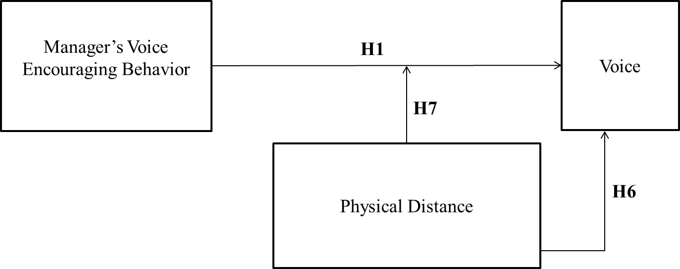
Figure 8. H1, H6 and H7 Theoretical Model.

In addition, consistent with CLT, I explored whether the effects of distance are mediated by communication opportunities.
Correlational measurements included in Study 1 as well as an experimental design study employed in Study 4 test these hypotheses.
Study 1 - Correlational Study
Physical Distance
Method
In addition to the experimental design described earlier in this chapter, additional correlational measurements were included to test the impact of physical distance on voice
Additional correlational measurements. I asked respondents whether they currently have a direct manager. I asked those who answer affirmatively (93%) the following questions.
Office location. I asked respondents to mark the first response that most closely describes their location and physical distance from their manager, 1 = other country, 2 = same country, 3 = same city, 4 = same office building. Most respondents (88%) stated that their office is in either the same building (82%) or same campus (6%) as their manager’s office. The remaining 12% stated that their manager resides in a different city or country.
Overall communication with manager. I used four items to gage the frequency of written, phone, remote, and face-to-face communications with one’s manager, employing an 11-point frequency scale, 0 = rarely to 10 = extensively, such as, “How often do you share written correspondence with you manager (such as e-mails, etc.)?” and “How often do you meet with your manager in person, face-to face?”
Results
As can be seen in Table 8, the closer the manager’s office to the participant’s office, the higher is the reported voice (as well as listening by the manager, and reported communication). This correlation is consistent with H6.
Table 8
Mean, SD and Correlations of Office-Location and Overall-Communication with Real-Work Variables
 | Office Location | Overall Communication
M | 3.75 | 21.78
SD | .67 | 8.75
Office Location | - | .17
Manager Facilitative Listening | .17 | .36
Low-Futility | .09 | .32
Voice-behavior scale | .14 | .40
Note. N = 252. When r > .11 p < .05. These values are presented in boldface. The higher the score on office location, the closer the manager’s office is to the participant’s office.
I inspected the effect of distance on communication with a one-way ANOVA, which showed a linear effect F(3,266) = 3.78, p = .01, depicted in Figure 9.
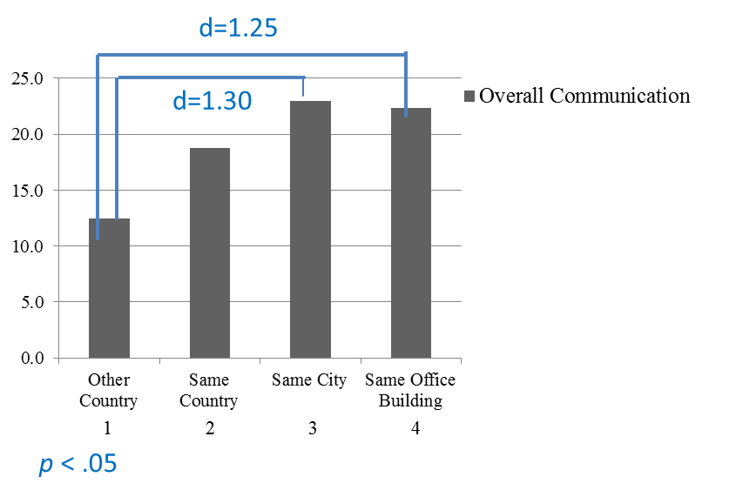
Figure 9. Overall communication by distance.
This effect shows both that one condition of mediation is present (the independent variable of distance affects the mediator variable of communication) and that I can treat distance as a continuous variable. Thus, I next computed a Sobel test with a boot-strapping analysis testing the mediation model as depicted in Figure 10.
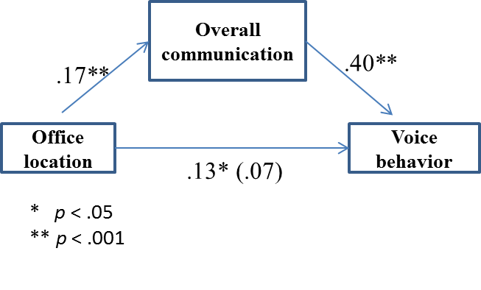
Figure 10: Sobel-test results
Figure 10 suggests that office location may affect voice partly through the opportunity to communicate.
To test H7, I regressed voice on voice-encouraging behavior (measured with manager’s listening), distance, and their interaction. However, I did not find evidence for this interaction, β = -.03, p = .57. Given this failure, in Study 4 I sought to retest H7, as well H1, and H6, with an experimental design.
Study 4 - Experiment
The Direct and Moderating Effect of Physical Distance on Voice
Method
Participants.
Surveys were distributed to 214 adult employees (140 male, 12 did not indicate gender).
Procedure.
Web-based surveys were distributed to multinational adult employees. Participants were presented with a scenario and asked to fill out a short survey in English on the web. Each participant was presented with one scenario out of six. The scenarios manipulated Voice encouragement (low, neutral, high) X Physical distance (close, far). (Non) Voice encouragement was manipulated using similar scenario as in Study 1, with the following text: "Your manager is usually (not) approachable to you and (not) responsive to your needs and requests. You feel that your manager (doesn’t) understand you. Your previous experience talking to your manager was (not) positive." In the neutral condition, no information about voice encouragement was provided.
Physical Distance was described in the “far” condition, as “Your manager is located in a different country with a 6-hour-time zone difference from your location. You and your manager do not share the same native language and thus communicate in English.” In the close condition respondents read that “Your manager’s office is located a few offices from your own office within the same corridor. You and your manager share the same native language.” Next, respondents read that "Given the situation described above, while working on a work related project you are not sure at some point about the best way to proceed. Progressing in the wrong direction may lead the project to failure or result in delays or financial losses." Next, participants were asked to answer the DV questions and demographic questions.
Measurements.
Distance manipulation check: “How close are you to your manager” (0 = Not at all and 10 = Very much)?
Voice-encouragement manipulation: “To what extent (degree) do you feel your manager understands you” (0 = Not at all and 10 = Very much)?
Voice. “How likely are you to voice this concern to your manager” (0 = Not at all and 10 = Very much)? Voice was negatively skewed and thus was transformed by raising the voice score to the power of four.
Demographics. I asked respondents to report age, gender, country of birth, country of residence, and years of work experience.
Analysis and Results
Table 9 and Figure 11 presents the means of voice by voice encouragement and distance. Table 10 shows a two-way ANOVA testing my hypothesis. As the Table indicates the results were in the predicted direction both for H1 and H6 (the main effects), but not for the interaction.
Table 9
Ns, Means, SDs of Voice by Physical Distance and Perception of Voice Encouragement
 | Physical Distance
 | Close |  |  |  | Far
Perception of Voice Encouragement | N | M | SD |  | N | M | SD
Low | 41 | 7129.56 | 4640.56 |  | 24 | 7410.0 | 4653.07
Neutral | 45 | 10461.51 | 4944.01 |  | 31 | 7909.23 | 4538.52
High | 41 | 9159.73 | 4947.96 |  | 32 | 8062.5 | 4844.69
Note. Voice was negatively skewed and thus was transformed by raising the voice score to the power of 4.

Figure 11. Means of Voice by Physical Distance and Perception of Voice Encouragement

Table 10.
 | df | F | p | Effect Size
Voice encouragement(A) | 2,214 | 2.75 | .07 | η² = .026
Physical distance(B) | 1,214 | 2.82 | .095 | d = 0.24
A x B | 2,214 | 1.46 | .23 | η² = .014
Voice Encouragement and Physical Distance Main Effects and Interaction

Yet, I further probed the data for the possibility of an interaction. Indeed, I ran two separate one-way ANOVA on the effect of voice encouragement, separately in each of the distance conditions. When physical-distance was far, voice enragement had no effect on voice, F(2, 86) = 0.13, p = .87. In contrast, when physical-distance was close, the effect of voice encouragement of voice approached significance, F(2, 126) = 5.11, p < .07.
These results may indicate that, voice encouragement does not significantly affect voice when distance is far, but a high level of voice encouragement increases voice when distance is close.
Study 4 has some measurements limitations. First, the voice-encouragement manipulation and manipulation check are confounded with manager’s approachability, responsiveness and understanding of the employee that are beyond voice-encouragement. Second, the distance-manipulation check asked the respondents “How close are you to your manager”. Closeness is not limited to physical distance. It may relate closeness in time, social distance, and other dimensions. Therefore, I cannot conclude that the respondents indeed responded to the physical-closeness dimension. This study, which was among the first I ran, is therefore lacking, and requires a more rigorous replication.
Discussion
The findings support again the beneficial effect of voice-encouragement on voice as hypothesized in H1. In addition, Study 4 and the correlational measures in Study 1 both support H6, indicating that physical distance reduces voice. Furthermore, Study 1 findings indicate a mediating effect of overall-communication such that physical distance reduces voice mediated by overall communication between employees and their managers. Finally, H7 – the moderating effect of physical distance on voice-encouragement to induce voice – is not supported.
Next, I analyze the potential effects of individual differences on voice in light of a voice-encouraging manager.

Individual Differences
Many individual-level differences have been documented to affect the level of voice of employees as described by Morrison (2011), “there is accumulating evidence that the frequency of voice depends on a variety of attitudes and dispositions, such that even within the same work context, some individuals may display significantly more voice than others.” (p. 393). In this section, I review the known correlation of ability, measured with performance, with voice, and the indirect evidence that propensity to trust also predicts voice. Next, I offer three constructs related to professional integrity and hypothesize that they also predict voice. Furthermore, I offer hypotheses according to which all of these individual differences have a three-way interaction together with manager’s voice-encouraging behavior and futility in predicting voice. Specifically, I hypothesize that high-performing employees, employees with a high propensity to trust and employees with high professional integrity as manifested by high consciousness, high felt-responsibility and high authenticity at work will interact with the model variables as follows, see Figure 12:
H8: Employee’s (a) high performance, (b) propensity to trust (c) consciousness (d) high felt-responsibility and (e) high authenticity at work induce voice.
H9: There will be a three-way interaction between manager’s voice-encouraging behavior, futility, and employee’s voice-enhancing individual differences (performance, propensity to trust, consciousness, felt-responsibility and authenticity at work). Specifically, when manager's voice-encouraging behavior is low, voice will be low. However, when manager's voice-encouraging behavior is high, there will be a two-way-interaction between futility and voice-enhancing-individual differences such that high voice-enhancing will lead to voice, even when futility is high.
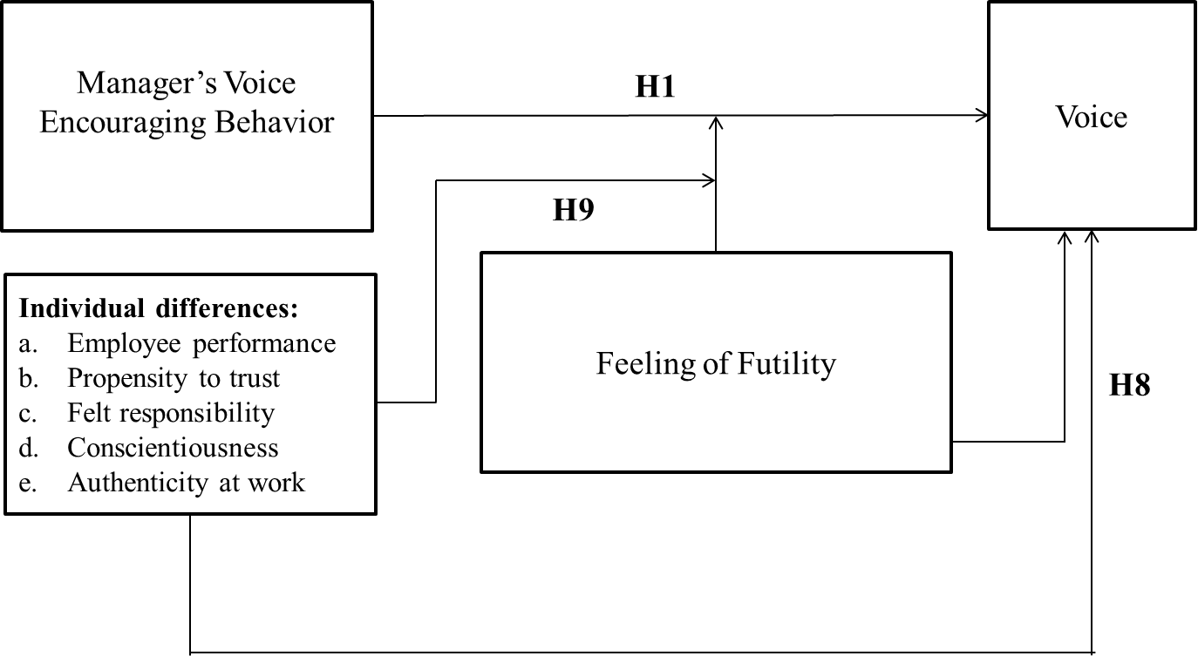

Figure 12. H1, H8 and H9 Theoretical Model.

Employee Performance.
High employee performance may lead employees to voice, especially when the manager encourages voice. Prior voice research indicated several reasons for increased voice of high-performers compared to low-performers. According to Ashford et al. this is because better performers believe they have more credibility and view voicing as their responsibility. Furthermore, they are more confident of their ability to provide important input (Brockner, Heuer, Siegel, Wiesenfeld, Martin, Grover, Reed, & Bjorgvinsson, 1998). Additionally, strong performers may have better impression-management skills and sensitivity to contextual cues as to what is welcome and what is not by those in power (Wayne & Liden, 1995). This suggests that better performers would be more likely than poor performers to voice when their managers appear interested and concerned. (Detert & Burris, 2007)
Indeed, voice is enhanced by manager's voice encouragement mostly among high performing employees (Detert & Burris, 2007) and among employees possessing high job efficacy (Tangirala & Ramanujam, 2012).
Propensity to Trust.
Organizational trust is defined by Mayer, Davis and Schoorman (1995) as:
The willingness of a party to be vulnerable to the actions of another party based on the expectation that the other will perform a particular action important to the trustor, irrespective of the ability to monitor or control that other party (p. 712).
When employees voice to their manager, they are willing to be vulnerable to the actions of their manager based on the expectation that the manager will perform a particular action important to the employee, irrespective of the employee’s ability to monitor or control the manager. Indeed organizational trust is positively correlated with voice (Gao, Janssen & Shi, 2011; Ng & Feldman, 2013). Furthermore, Gao et al. (2011) found that empowering leader behavior moderated the positive relation between leader trust and employee voice such that, for example, when leader trust was high, employee voice was higher when empowering leader behavior was high, but when the leader behaved in an empowering way, and leader trust was low, employee voice remained low. According to Mayer et al. (1995), trust for a trustee will be a function of the trustee's perceived ability, benevolence, and integrity and of the trustor's propensity to trust.
While ability, benevolence and integrity have been partially addressed in the current theoretical model, I also seek to analyze the unique additional effect of the employee’s propensity to trust. Propensity to trust is proposed to be a stable within-party factor that will affect the likelihood the party will trust (Mayer et al., 1995). It may be thought of as the general willingness to trust others. In a meta-analysis on trust in leadership, Dirks and Ferrin (2002) found a small but significant relationship between propensity to trust and trust in leadership. Colquitt, Scott and LePine (2007) found that propensity to trust is positively related to trust, controlling for ability, benevolence, and integrity. They have also found that the relationship between propensity to trust and risk taking is partially mediated by trust. In sum, propensity to trust may be a voice-enhancing factor such that it overcomes high-risk perception and possibly low-efficacy concerns as well.
Professional Integrity.
In the verbatim analysis of Study 2, the factor of professional integrity was raised as a reason to voice even high-risk topics to management. This appears to be a unique drive to voice the truth unrelated to, or in spite of the high risk or low efficacy of doing so. An employee’s drive to voice because of his or her professional integrity might be aligned with the findings of LePine and VanDyne (2001) that voice was positively related to conscientiousness. Another explanation may be that such a drive comes from a strong sense of authenticity at work, the degree to which a person acts in agreement with one’s true self in the workplace. Finally, professional integrity may be linked to an employee’s felt responsibility, which has been found to be positively related to employee’s taking-charge behaviors, because some forms of employee voice are viewed as taking-charge behaviors (Morrison & Phelps, 1999, Fuller et al., 2006). I analyze the employee’s feeling of professional integrity and the role it plays to induce voice, even when futility in voicing to upper management is high.
Study 1 - Correlational Study
The effect of individual differences on felt futility and voice
Method
In addition to the experimental design described earlier in this chapter, additional correlational measurements were included to test individual differences and their effect on voice
Procedure.
I randomly assigned the order of taking the individual-difference measure either before (47%) or after the presentation of the scenario experiment. The individual difference measures were presented in random order.
Individual Difference Measures.
Perceived-employee’s performance. I measured this construct with a modification of the suggestion by Gomez and Balkin (1989) based on the procedure suggested by Gupta and Govindarajan (1984): “Indicate the rating that most closely matches the most recent performance appraisal received from your manager”, from 0 = extremely low performer to 10 = exceptionally high performer.
Propensity to trust. I measured propensity-to-trust using items answered on a scale ranging from 0 = strongly disagree to 10 = strongly agree based on Mayer and Davis (1999) propensity to trust measure (see appendix A). Example items include “One should be very cautious with strangers,” and “Most people can be counted on to do what they say they will do,” α = .73.
Professional integrity. I used three measures to determine the employee’s perceived professional integrity: Felt Responsibility, Conscientiousness and Authenticity at work.
Felt responsibility. As suggested by Morrison and Phelps (1999), felt responsibility is positively related to employee’s taking-charge behaviors. Raising project-related risks and concerns to management is a form of taking-charge. Felt responsibility was measured based on the five items developed by Morrison and Phelps (1999) on a scale ranging from 0 = strongly disagree to 10 = strongly agree. Example items include “I feel a personal sense of responsibility to bring about change at work,” and “Correcting problems is not really my responsibility.” All items are presented in appendix A, α = .75.
Conscientiousness. LePine and Van Dyne (2001) analyzed the relationship between voice behavior and the Big-Five-personality dimensions. They have also tested the relationship between voice and all Big-Five narrower facets. In their analysis, the positive relationship between voice and conscientiousness was also related to five out of the six narrower traits of conscientiousness: competence, order, achievement striving, self-discipline and deliberation. Professional integrity may appear to align only with a partial subset of the narrow traits (e.g., competence, achievement striving) but due to the relationship between voice and all or most narrower traits of conscientiousness, it would suffice to test the overall dimensions and not necessarily ask about specific facets. Therefore, I assessed professional integrity, by assessing conscientiousness, assuming that conscientiousness is another reflection of professional integrity. Personality was measured with the 40-Item Mini Marker set developed by Saucier (1994). The reliability of the Big-Five personality dimensions measures yielded Cronbach’s α = .72 for Extroversion; Cronbach’s α = .79 for Agreeableness; Cronbach’s α = .81 for Conscientiousness; Cronbach’s α = .78 for Neuroticism; and Cronbach’s α = .69 for Openness;
Authenticity at work. Another reflection of professional integrity may be found in authenticity at work, the degree to which a person acts in agreement with one’s true self in the workplace. To measure authenticity, I used the Individual Authenticity Measure at Work (IAM Work) 12-item scale (Bosch & Taris, 2013) on a Likert-type scale ranging from 0 = does not describe me at all to 10 = describes me very well. Example items include: “At work, I always stand by what I believe in” and “I behave in accordance with my values and beliefs in the workplace”. All items are presented in appendix A, α = .88.
Analysis and Results
To test H8, I used two different measures of voice: the voice reported in response to the experimental scenarios, and the voice reported at the work setting. As can be seen in Table 11, each of the measures of voice-enhancing-individual differences was positively correlated with both measure of voice, thus supporting H8, where performance, felt responsibility, and authenticity showed relatively strong correlations with both the experimental-voice and real-work voice measures, and Conscientiousness showed a relatively strong correlation with the real-work voice measure.
Table 11.
Correlations of main experiment variables: Experiment conditions, manipulation checks, voice, and individual difference variables
Individual Differences | M | SD | Voice in the experiment | FLS | Futility | Real-work Voice
Performance | 7.47 | 2.22 | .29 | .46 | .53 | .51
Propensity to trust | 4.56 | 1.71 | .15 | .15 | .10 | .17
Felt Responsibility | 6.68 | 2.03 | .35 | .33 | .33 | .54
Conscientiousness | 8.78 | 1.46 | .17 | .46 | .39 | .48
Authenticity at Work | 7.65 | 1.35 | .29 | .39 | .28 | .42
Note. 300 ≤ N’s ≤ 330; r’s ≥ |.12| are significant at p < .05 (two-tailed).

To test H9 on the voice reported in the experiment,. I ran three-way ANCOVAs with the two experimental factors as discrete predictors, and the voice-enhancing-individual differences as continuous predictors (see Table 12). As can be seen in Table 12, performance predicted voice, but did not interact with any of the manipulated factors. Thus, H9a is not supported. Similar results were obtained with the other voice-enhancing-individual differences. Hence, H9 in general is not supported with the voice measured in the scenario experiment.

Table 12.
Voice by Voice encouragement, Felt Futility, Performance, and interactions
 | Df | F | p | η²
Voice encouragement(A) | 2,305 | 2.46 | .09 | .016
Felt Futility(B) | 1,305 | 2.57 | .11 | .009
Employee’s performance(C) | 2,305 | 35.59 | .00 | .108
A x B | 2,305 | 1.21 | .30 | .008
B x C | 1,305 | 0.04 | .83 | .000
A x C | 2,305 | 2.12 | .12 | .014
A x B x C | 2,305 | 0.29 | .75 | .002

To test H9 on the voice reported at work, I regressed real-work voice on the managers’ voice-encouraging behaviors (FLS), futility, each of voice-enhancing-individual differences, all three two-way interactions, and the three-way interaction. All the voice-enhancing individual-differences main effects were significant in support of H8. However, with one exception, none of the 2-way and 3-way interactions relating to the voice-enhancing individual-differences were found to be significant. The only significant 3-way interaction was with conscientiousness (see Table 13). To facilitate the interpretation of the three-way interaction, I tested the two-way interactions of voice-encouraging behaviors (FLS) with futility, separately of participants above and below the median in conscientiousness (see Table 14 and Figure 13). The results are consistent with H9, but should be interpreted with caution due to experiment-wise-error rate.
Table 13.
Regression of real-work voice on the managers’ voice-encouraging behaviors (FLS), futility, conscientiousness, and interactions.
 | B | SE B | β | t | p
FLS (A) | 0.19 | 0.06 | 0.18 | 2.97 | 0.003
Futility (B) | 0.37 | 0.09 | 0.23 | 4.17 | 0.000
Conscientiousness (C) | -0.03 | 0.04 | -0.04 | -0.71 | 0.479
A x B | 0.05 | 0.02 | 0.14 | 2.35 | 0.020
A x C | -0.03 | 0.04 | -0.04 | -0.71 | 0.479
B x C | 0.02 | 0.04 | 0.02 | 0.41 | 0.686
A x B x C | -0.03 | 0.01 | -0.14 | -2.27 | 0.024
R² |  |  | 0.36
Adjusted R² |  |  | 0.34
F |  |  | 23.63 |  | 0.001

Table 14.
Regression of voice-encouraging behaviors (FLS) with futility, separately for participants below (a) and above (b) the conscientiousness median.
 |  | (a) Participants below conscientiousness median |  |  |  |  | (b) Participants above conscientiousness median
 |  | B | SE B | β | t | p | B | SE B | β | t | p
FLS (A) |  | 0.39 | 0.08 | 0.44 | 4.75 | 0.00 | 0.44 | 0.10 | 0.45 | 4.61 | 0.00
Futility (B) |  | 0.24 | 0.09 | 0.21 | 2.60 | 0.01 | 0.11 | 0.09 | 0.12 | 1.32 | 0.19
A x B |  | 0.09 | 0.03 | 0.26 | 2.99 | 0.003 | 0.03 | 0.03 | 0.10 | 1.22 | 0.22
R² |  |  |  | 0.24 |  |  |  |  | 0.27
Adjusted R² |  |  |  | 0.22 |  |  |  |  | 0.25
F |  |  |  | 15.36 |  | 0.00 |  |  | 18.29 |  | 0.00

Figure 13. Two-way interactions of real-work work manager-facilitative-listening and high/low efficacy (low/high futility) separately for participants below (a) and above (b) the conscientiousness median.
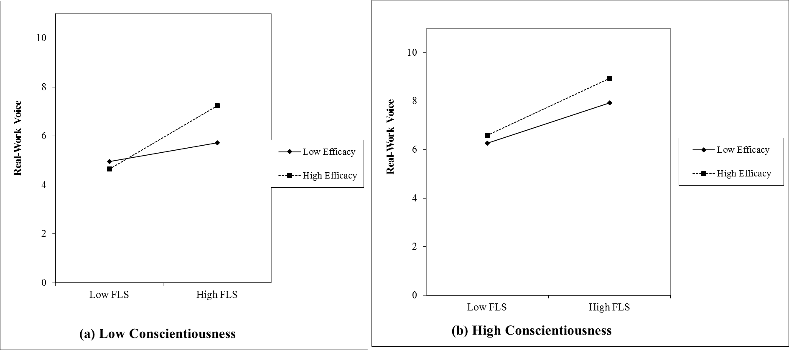

Chapter 3 Discussion
The research presented in this chapter replicates some of the documented findings regarding employee-voice behavior, and expands these findings in several ways.
Manager’s voice-encouraging behavior induces voice. All four studies presented in this chapter have found that when managers encourage their employees to speak, voice is higher than when managers do not do so. These findings are in line with previous work (Ashford et al., 1998, Detert & Burris, 2007, Miceli, Near, & Dworkin, 2008, Milliken et al., 2003, Saunders et al., 1992), and support H1.
Voice-reducing variables. As hypothesized, voice was reduced by felt-futility (H2; Study 1; consistent with Milliken et al., 2003, Saunders et al., 1992); by perceived risk (H4; Study 3; consistent with e.g., Ashford et al., 1998, Milliken et al., 2003, Morrison & Milliken, 2000); and by physical distance between the manager and the employee (H6; Study 4), albeit, the effect of physical distance was mediated by overall-communication between manager and employee in Study 1.
In sum, as noted by Morrison (2014), “There are often opposing forces acting upon the employee, both those that are pulling in the direction of speaking up and those that are pulling in the direction of remaining silent.” (p. 185). Manager’s voice-encouraging behavior appears to be a factor pulling the employee in the direction of speaking up. Felt-futility, perceived risk and physical distance are examples of forces that pull the employee in the direction of remaining silent.
Moderating effects of the voice-reducing variables. This chapter explores the moderating effects of the three variables on the beneficial effect voice-encouragement has on voice. Indeed, the benefit of physical distance was attenuated when felt-futility is high (H3; Study 1). This findings further contributes to the understanding of opposing forces that affect voice. Yet, the effect of voice-encouragement on voice, was inconsistently moderated by perceived risk (H5; partial support in Study 2; no support in Study 3), and was not moderated by physical distance (H7; Study 4).
The impact of individual differences. Study 1 replicated previous findings regarding the positive relationship between voice and high-performing employees (e.g. Detert & Burris, 2007 and Van Dyne, Kamdan & Joirman, 2008), conscientiousness (LePine & VanDyne, 2001), and felt-responsibility (Morrison & Phelps, 1999, Fuller et al., 2006). Furthermore, Study 1 supports a positive relationship between voice and propensity-to-trust and between voice and authenticity-at-work. The latter two are new findings, and in concert support H8 (Study 1). These may suggest that some of the forces dictating voice are outside management control, as they depend on employees’ individual differences.
The hypothesized three-interaction between individual differences, voice-encouraging management, and futility was largely unsupported (H9; Study 1). The single significant three-way interaction (with conscientiousness) may suggest that some individual differences may be forces that counteract the effects of voice-reducing variables, such as futility. However, this should be tested in future research with much larger samples to allow sufficient power to detect such complex effects. In addition, future research may focus on additional individual differences such as tenure and extroversion to test their potential moderating effect on manager’s voice-encouraging behavior and employee’s felt-futility.
Limitations of the current studies
The studies described have several limitations. Scenario experiments have limited ecological validity because they measure intention to voice, and not actual voice behavior. In addition, self-report response may cause mono-method bias. This problem is overcome for variables manipulated experimentally, and somewhat controlled by randomizing order of questionnaires (no order effects found).
Implications
This research raises some interesting practical implications. First, it re-emphasizes the importance of management’s voice-encouragement behavior to induce voice. Second, it helps to frame some of the reasons for reduced voice even in an encouraging environment. For example, perceived futility may reduce voice even when the manager tries to encourage it. Thus, informed managers may wish to listen specifically to the concerns regarding futility before they can hope to induce voice. Moreover, managers may wish to attribute positive change to the voice of various employees, when this is true, as to signal to their staff that voice is not futile. In addition, the voice-reducing effects of physical distance and overall reduced communication between managers and employees are important to understand in today’s global working environments. Management’s awareness, and concrete steps to increase communication in order to mitigate the challenge may help to increase voice even in highly distributed teams.

CHAPTER 4 – Voice Topics
In this chapter, I further expand the scope of the construct of voice. The voice literature is focused largely on constructively challenging the status quo (Van Dyne & Lepine, 1998). However, within this definition, different topics and content may yield varying levels of voice. Morrison (2014) suggests that it may be beneficial to distinguish between promotive voice, like suggestions and new ideas, and prohibitive voice, such as raising problems. Furthermore, Milliken et al. (2003) identified reasons for employees remaining silent, among which are being labeled or viewed negatively, potential to damage relationships, and negative impact on others. Hence, within the realm of constructively challenging the status quo, employees may choose to voice some topics more than others. For example, topics that may have negative impact on team members may be voiced less than topics that are technical in nature. Morrison (2014) states, in the conclusion of her comprehensive review of motivational processes that affect whether employees engage in upward voice, that:
There are many forces that hold employees back and make them reluctant or unwilling to speak their minds. Organization leaders, therefore, need to foster conditions that motivate and enable voice while at the same time breaking down inhibitors, such as the often legitimate fear of being dismissed or viewed negatively. (p. 193).
However, even when the manager is voice encouraging, I suggest that some topics will nevertheless be avoided. Specifically, any topic that may put the employee in negative light (sharing information about a colleague that affect work) is more likely to be avoided than topics that put the employee in positive light (sharing information that is project related).
H10: Voice topics that may have negative implications for the image of the employee (regarding moral character, personal and professional abilities) will be voiced less than topics that may have positive implications for the image of the employee (originality, commitment).
H11: There will be an interaction between voice topic and manager’s voice encouragement, such that voice encouragement increases voice more for topics that may have positive implications for the image of the employee than for topics that may have negative implications for the image of the employee.
Moreover, I speculate that the difference in voice rate among different topics will be most pronounced among employees exhibiting (a) high performance, (b) high sense of professional integrity, and (c) a low propensity to trust. I suspect this moderation because poor performer may avoid voice altogether, while good performers may wish to emphasize their task contribution through voice regarding the task. Similar effect may be found for employees with high professional integrity. In contrast, employees with high propensity to trust may be willing to share even topics that can put them in negative light, and thus low propensity to trust may reveal differences among topics. Therefore, I explored the following question:
RQ1: Do the individual differences of performance, professional integrity, and propensity to trust moderate the effect of voice topic?
See Figure 14.
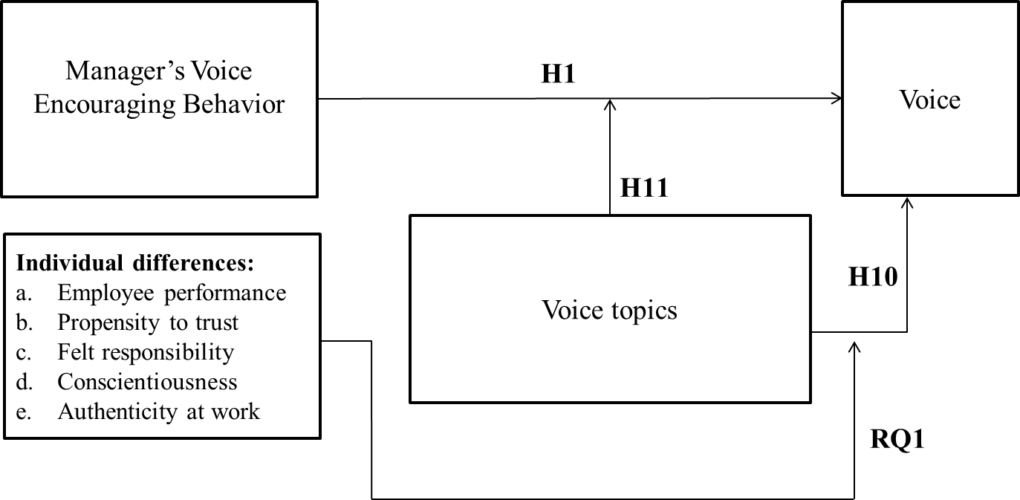
Figure 14. H1, H10, H11 and RQ1 Theoretical Model.

This chapter reviews three studies that explore level of voice for varying topics from several standpoints. Study 1 measures the employee’s perceived frequency of voice as a function of topic, and assesses if topics that may have negative implications for the image of the employee (regarding moral character, personal and professional abilities) will receive less voice than topics that may have positive implications for the image of the employee (originality, commitment), testing H10. Additionally, this study also tests the effect of the individual differences presented in Chapter 3 on the frequency of voice topics, addressing RQ1.
Study 5 measures perceived voice as a function of topic, under conditions of high and low voice-encouraging management, testing H11.
In light of the results of these studies, I sought to learn about managers’ perceptions regarding the frequency and importance of the same voice topics. Therefore, Study 6 explores this question from the manager’s standpoint. That is, in all three studies respondents were asked about a consistent set of six work-related topics: project-related information, work-related requests, project-related questions and dilemmas, ideas related to a new project, personal information that may impact work performance, and work-related information regarding a colleague from the team.
Thus, I also explored the following question:
RQ2: Do managers’ perceptions of the frequency of various voice topics mirror employees’ perception? Does the frequency of various topics mirror perceived importance of these topics?
I begin with reviewing Study 1 to test H10 and to explore RQ1.

Voice-Attenuating Topics
Study 1 - Correlational Study
The effect of voice topics on voice
Method
In addition to the experimental design described earlier in Chapter 3, additional correlational measurements were included to test various voice topics and their effect on voice
Additional measurements.
Voice topics raised to the manager was measured on a frequency scale (0 = Almost never to 10 = Almost always) regarding six voice topics: “I share project related information with my manager”, “I share personal information with my manager”, “I share project related questions and dilemmas with my manager”, “I share new project related ideas with my manager”, “I share work related requests with my manager” and “I share work related information regarding a colleague with my manager”
To test the differences among the means (Table 15), I ran one-way repeated-measures ANOVA on frequency to voice. Prior to the test, I detected a violation of the assumption of sphericity, and thus I used an ANOVA with adjusted degrees of freedom. Despite this violation, the difference between topics is large and highly significant, F(3.22, 986.1) = 127.5, p < .001, η² = .294.
Table 15.
Means (M) and Standard Deviation (SD) of voice frequency ratings by voice topic.
 |  |  |  | CL
Topic | M |  | SD | LB | UB
Project related information | 7.06ª |  | 2.84 | 6.74 | 7.38
Personal information | 5.00^{b} |  | 3.07 | 4.66 | 5.35
Project related questions and dilemmas | 6.91^{c} |  | 2.77 | 6.60 | 7.21
New project related ideas | 6.72^{c} |  | 2.79 | 6.40 | 7.03
Work related requests | 7.16ª |  | 2.65 | 6.86 | 7.45
Work related information regarding a colleague | 4.40^{d} |  | 3.23 | 4.03 | 4.76
Note. N = 307. Means not sharing a superscript are significantly different according to HSD test at the .05 level.
The pairwise comparisons in Table 15 show topics that are voiced significantly less are personal information, and work related information regarding a colleague. Additionally, topics that have some level of challenging the status quo, specifically new project ideas and project related questions and dilemmas, have significantly lower voice levels than project related information and work related requests. See Figure 15.
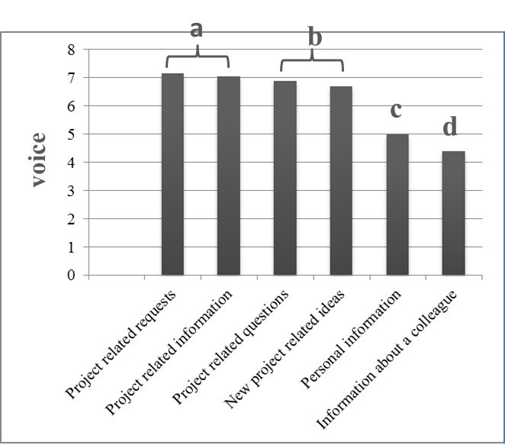
Figure 15. Voice-frequency means by voice topics

I further probed these data with multi-dimensional scaling, which yielded two sets: Work-Related Topics (M = 6.9, SD = 2.53, α = .94) and Personal Topics (M = 4.7, SD = 2.74, α= .68). Not surprisingly, a significant difference between work-related vs. personal topics was found F(1, 306) = 283.25, p < .001, η² = .481. Cohen’s d for repeated measures, based on Morris and DeShon, 2002 yielded d = 0.97. These results support H10.
Individual Differences. To explore RQ1, I next analyzed the effect of individual differences on frequency of voice topics. Results can be found in Table 16.
Table 16.
Interaction of voice topics with individual differences
 | F | p | η²
Topics * Performance | F(1, 304) = 11.4 | .001 | .036
Professional integrity variables
Topics * Felt Responsibility | F(1, 304) = 12.9 | .001 | .041
Topics * Conscientiousness | F(1, 304) = 20.9 | .001 | .064
Topics * Authenticity at work | F(1, 302) = 10.9 | .001 | .035
Topics * Propensity to Trust | F(1, 302) = 3.70 | .06 | .012

Table 17 and Figure 16 show the direction of the interactions. To simplify presentation of the results, I report below for professional-integrity only the results obtained with felt responsibility. Results for conscientiousness and authenticity- at-work are similar.
As can be seen in Figure 16, as performance and professional integrity increases, voice increases, but especially for topics that may have positive implications for the image of the employee, rather than for topics that may have negative implications for the image of the employee. In contrast, as propensity trust decreases, voice decreases, but especially for topics that may have negative implications for the image of the employee, rather than for topics that may have positive implications for the image of the employee. However, the interaction effect with propensity-to-trust was marginal.
Table 17.
Main correlations of voice topics and individual differences
 | Personal topics | Work-related topics
Work-related topics | .61
Performance | .27 | .47
Propensity-to-trust | .23 | .15
Felt-responsibility | .27 | .48
Note. p < .01
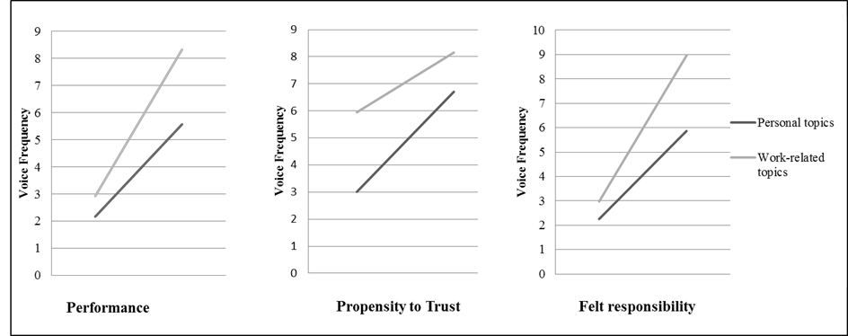
Figure 16. Voice topics and individual differences regression lines.
The findings of Study 1 support H10 and provide interesting insight as per RQ1. I next review Study 5 to test the effect of manager’s voice-encouraging behavior on voice topics.
Study 5
The Moderating Effect of Various Voice Topics on Voice
Method
Participants.
As part of a larger study, web-based surveys were distributed in a multi-national corporation to Israeli, Indian and North American employees (N = 57; 25 female). Israeli participants responded in Hebrew and the other nationalities in English.
Procedure.
A (2)x(2)x(6) repeated scenario design was used. Participants were presented with 24 scenarios manipulating Employee wants to speak (yes vs. no) X Manager wants to listen (yes vs. no) X Voice topic (project related information, personal information, project related questions and dilemmas, new project related ideas, work related requests, work related information regarding a colleague from the team). Two example scenarios are "I am sharing personal information with my manager and my manager is listening to me"; and “I am sharing a new work related idea with my manager and my manager is not listening to me”.
Measurements.
Frequency of voice. Respondents were asked to read the 24 scenarios and rate "How often do the below scenarios occur", on a scale ranging from 1 = never to 10 = very often).
Demographics. I collected data on gender, years of experience, country of birth, and residence.
Results
Means and SDs of voice-frequency ratings by employee willingness to voice, manager listening, and voice topic are presented in Table 18.

Table 18.
Means (M) and Standard Deviation (SD) of voice frequency ratings by employee willingness to voice, manager listening, and voice topic.
 | Employee wants to speak |  |  |  | Employee doesn’t want to speak
 | Manager wants  to listen |  | Manager doesn’t  want to listen |  | Manager wants  to listen |  | Manager doesn’t  want to listen
Topic | M | SD | M | SD | M | SD | M | SD
Project related information | 8.12ª | .20 | 3.90 | .50 | 5.49 | .53 | 3.98 | .52
Personal information | 6.68^{bc} | .33 | 3.83 | .47 | 4.77 | .39 | 5.00 | .47
Project related questions and dilemmas | 7.83^{ac} | .25 | 3.95 | .51 | 4.98 | .50 | 3.51 | .47
New project related ideas | 7.49^{abc} | .30 | 3.79 | .50 | 5.23 | .51 | 4.04 | .51
Work related requests | 8.09ª | .20 | 3.75 | .49 | 5.04 | .50 | 4.07 | .52
Work related information regarding a colleague | 6.42^{b} | .40 | 4.46 | .54 | 5.65 | .49 | 4.70 | .49
Note: N = 57. Means that do not share subscripts differ by p < .05
A three-way repeated-measures ANOVA with 2 (management listening) x 2 (employee willingness to voice) x 6 (topics) was conducted on the voice frequency ratings. As can be seen in Table 19, all the two-way interactions were significant. To interpret these interactions, I ran a within-subject ANOVA on voice topic, separately in each combination of the other variables. As can be seen in Table 20, the only meaningful effect of topic is found when both the employee wants to talk and the managers listens. That is, although the three-way interaction in Table 19 did not reach significance, the results of Table 20 hints at this possibility. To interpret the effect of voice topic when both employee wants to talk and manager listens, I plotted the means of voice frequency in Figure 17.
Table 19
Repeated-measure ANOVA: Frequency of Voice by Employee’s Willingness to Voice, Manager’s Willingness to Listen, and Topic
 | df | F | p
Employee’s willingness to voice (A) | 1, 56 | 19.60 | .001
Manager’s willing to listen (B) | 1, 56 | 37.7 | .001
Voice topic (C) | 4.63, 259.1 | 0.58 | .70
A x B | 1, 56 | 29.23 | .001
A x C | 4.50, 252.2 | 2.73 | .03
B x C | 4.74, 265.6 | 4.63 | .001
A x B x C | 4.52, 253.4 | 1.55 | .18

Note. df corrected where assumption of sphericity has been violated.
Table 20.
Two-Way ANOVAs testing the Effect of Voice Topic on Voice Frequency, in Four Experimental Cells.
 | Employee wants to talk |  |  | Employee doesn’t want to talk
 | df | F | p | df | F | p
Manager wants to listen | 3.27, 196.13 | 10.46 | .001 | 5, 295 | 0.56 | .73
Manager doesn’t want to listen | 4.57, 269.39 | 0.65 | .65 | 4.76, 280.6 | 2.36 | .06
Note. Degrees of freedom corrected where assumption of sphericity has been violated.

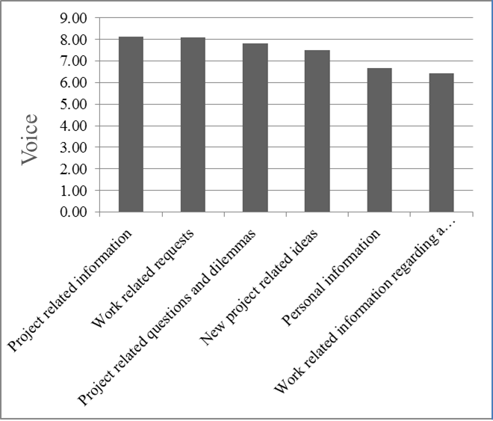
Figure 17. Means of voice frequency when employee wants to talk and manager wants to listen.
The results depicted in Figure 17 (and tested in the upper-left panel of Table 20) are consistent with H11. That is, even when the manager is listening (and employee indicate that they want to voice), frequency of voice is lower for personal topics relative to frequency of voice for project- or work-related topics.
Discussion
As reviewed in Study 1, employees rated the frequency of voice regarding either personal or work-related information regarding a colleague significantly less than work-related topics. Therefore, voice topics that may put the employee in a negative light are raised significantly less than pure or promotive work-related topics. These results lend support to the work done by Milliken et al. (2003) and support H10.
Furthermore, individual differences interact with voice topics moderating the frequency of voice such that work-related topics are raised more than personal and potentially image-harming topics in all cases, but the gap increases for high-performing employees and employees that have a high level of professional integrity while it reduces for employees with high level of propensity-to-trust. These findings provide initial insight to RQ1.
Study 5 tests the effect of manager’s voice-encouraging behavior. I find that the beneficial effect of voice encouragement on voice is moderated by voice topics, such that work-related and promotive topics will induce more voice than topics that may view the employee in a negative light. These findings support H11. Interestingly, when managers did not encourage voice, the frequency of voice reduced for all topics, and there was no significant difference in the frequency between the various topics. This finding lends additional support to H1.

Manager’s Perception
Having tested frequency of voice topics from the perception of the employee, I next seek to explore RQ2 and analyze managers’ perception of the frequency and importance of voice regarding the same six voice topics.
Study 6
Manager’s Perspective on the Frequency and Importance of Various Voice Topics
Method
Participants.
Web-based surveys were distributed to 99 US-based managers (39 female).
Procedure.
Participants were first asked to select one employee from their team and to answer all employee-related questions regarding this specific employee. Next, a (2)x(6) repeated scenario design was used. Participants were presented with 12 scenarios as follows: Type of rating (importance of voice vs. frequency of voice) X Voice topic (project related information, personal information, project related questions and dilemmas, new project related ideas, work related requests, work related information regarding a colleague from the team). Two example scenarios are "It is very important for me to hear from this employee about project related information” and “This employee shares new work related ideas with me”. The order of questions was randomized such that 53% of the respondents were asked to rate the frequency of voice before rating the importance of voice, and the rest of the respondents were asked to first rate the importance and then the frequency. No order effects were found. Next, participants were asked to rate the performance of the selected employee and respond to some demographic questions.
Measurements.
Importance of voice. Respondents were asked to read six scenarios (see Procedure) and to indicate "It is important to you to hear about these topics from your employee" on a scale ranging from 0 = Strongly disagree to 10 = Strongly agree.
Frequency of voice. Respondents were also asked to indicate for each of the six scenarios "How often do the below scenarios occur" on a scale ranging from 0 = never to 10 = very often.
Employee performance. “Please indicate the rating that most closely matches the most recent performance appraisal you gave this employee” on a scale ranging from 0 = Extremely low performer to 10 = Extremely high performer.
Demographics. Gender, years of experience, country of birth and residence
Results
Means and SDs of voice frequency and importance ratings by voice topic are presented in Table 21, and the repeated ANOVA pertaining to these data in Table 22. As can be seen in Table 22, type of rating, topic of voice and their interaction are significant. To interpret this interaction, I plotted in Figure 18 the ratings, coupled with Cohen’s d for repeated measures based on Morris and DeShon (2002) showing the difference between frequency and importance of voice per topic.
Table 21.
Means (M) and Standard Deviation (SD) of manager’s perception of employee’s voice frequency and importance of voice topics
 | Frequency of voice |  | Importance of topic
Topic | M | SD | M | SD
Project related information | 8.23^{ab} | 2.08 | 9.17^{ab} | 1.92
Personal information | 5.94 | 2.43 | 4.94 | 2.60
Project related questions and dilemmas | 8.23^{ac} | 1.73 | 9.17^{ac} | 1.80
New project related ideas | 7.33 | 2.36 | 8.75^{d} | 1.93
Work related requests | 8.03^{bc} | 2.01 | 8.86^{bcd} | 1.80
Work related information regarding a colleague | 6.73 | 2.57 | 7.98 | 2.38
Note: N = 99. Means that do not share subscripts within the column differ by p < .05

Table 22.
Repeated-measure ANOVA of Manager’s perception of frequency and importance of voice and topic, Main Effects and Interaction
 | df | F | p | η²
Frequency/Importance of voice (A) | 1, 98 | 23.08 | .001 | .191
Voice topic (B) | 3.36, 329.6 | 62.25 | .001 | .388
A x B | 4.05, 396.7 | 22.13 | .001 | .184
Note: df corrected where assumption of sphericity has been violated

Figure 18. Means of voice frequency and importance as perceived by managers.
Cohen’s d for repeated measures based on Morris and Deshon (2002)

As can be seen in Figure 18, managers’ perception of the importance of the topics is significantly higher than their frequency, except personal-information which is perceived to be less important than the frequency it is raised. Beside, this interaction effect, Figure 18 shows again that the frequency of voicing topics that are either personal ore relating to information about a colleague is lower than the other topics, consistent both with previous results and with H10, only that this time the source for this information is the manager, as opposed to employees (in previous studies).
Auxiliary Analyses.
Individual differences – Employee’s performance. In this study, managers were asked to rate the performance of the employees, and I tested the effect of employee’s performance on the manager’s perception of both frequency and importance of voice topics. In line with findings of Study 1, I found a significant interaction between employee’s performance and both importance of topics, η2 = .045 and frequency of topics, η2 = .029. The correlation matrix in Table 23 helps to understand the direction of these interactions. As can be seen from the correlations, while there is a positive significant relationship between the frequency and importance of the work-related voice topics and performance, no such relationship exists for the personal topics. That is, managers perceive the frequency and importance of work-related topics to increase as performance of the employee increases, but no such relation exists for the personal topics. Moreover, as can be seen, in the last column of Table 23, frequency and importance are correlated but not redundant.
Table 23
Correlations between Performance and Frequency, Performance and Importance, and Frequency and Importance of Voice-Topics.
Topics | Frequency – Performance | Importance – Performance | Frequency – Importance
Project Related Information | .43** | .42** | .50**
Personal | .04 | -0.08 | .51**
Project Related questions | .35** | .36** | .26*
New project Ideas | .29** | .31** | .41**
Work related requests | .22* | .39** | .20*
Information about a colleague | .04 | .09 | .62**
Note. N = 99. * p < .05; ** p < .01
Comparison to employees’ data. Given that in this study I asked managers the same question (voice frequency) as I asked employees in a previous study, I explore below the differences in their perspectives. In Table 24, I copied the relevant data from Tables 15 and 21.
Table 24
Means (M) and Standard Deviation (SD) of Voice Frequency Reported by Employees and Managers
 | Employees  N = 307 |  | Managers  N = 99
Topic | M | SD | M | SD | d
Work related requests | 7.16 | 2.65 | 8.03 | 2.01 | 0.37 | **
Project Related Information | 7.06 | 2.83 | 8.23 | 2.08 | 0.47 | **
Project Related questions | 6.91 | 2.77 | 8.23 | 1.73 | 0.57 | **
New project Ideas | 6.72 | 2.79 | 7.33 | 2.36 | 0.24 | *
Personal information | 5.00 | 3.07 | 5.94 | 2.43 | 0.34 | **
Information about a colleague | 4.40 | 3.24 | 6.73 | 2.57 | 0.80 | **
Note. d = Cohen’s d for repeated measures, based on Morris and Deshon (2002).
* p < .05; ** p < .01

As can be seen Table 24, for all six voice topics, managers perceived voice to be significantly more frequent than the frequency perceived by the employees. That is, managers appear to overestimate voice, and perhaps more so regarding information about a colleague.
Discussion
Study 6 explores RQ2 and analyzes the perception of managers regarding the frequency of which various voice topics are raised, and the importance of these topics. First, managers perceive topics that may shed the employee in a negative light to be voiced less frequency than promotive work-related topics. In addition, frequency and importance of voice interact with the individual difference of employee performance. These findings are aligned with the findings of Study 1 and provide additional support to H10. Furthermore, the importance of almost all voice topics, with the exception of personal topics, is perceived to be higher than the frequency of which they are raised. Moreover, comparing employees and managers perception by viewing Study 1 and Study 6, indicates that employees report voice significantly less frequently than the manager’s perception of their doing so.

Chapter 4 Discussion
The research presented in this chapter seeks to distinguish between different types of topics as predictors to voice and as moderators to the beneficial effect of voice-encouraging managers. It further analyzes the effect of individual differences on the various topics to predict voice. Finally, it tests managers’ perception regarding the frequency and importance of the varying topics shedding light on potential perception gaps between managers and their employees.
Voice topics that may put the employee in a negative light are raised significantly less than pure or promotive work-related topics. As reviewed in Study 1, employees rated the voice frequency of personal and work-related information regarding a colleague from the team significantly less than work-related topics. These results lend support to the work done by Milliken et al. (2003) and support H10.
The effect of voice encouragement on voice-topics as a predictor of voice. As found in Study 5, the beneficial effect of voice encouragement on voice is moderated by voice topics, such that work-related and promotive topics will induce more voice than topics that may put the employee in a negative light. Interestingly, when managers did not encourage voice, the frequency of voice reduced for all topics, and there was no significant difference in the frequency between the various topics. This finding lends additional support to H1, and may hint at manager’s voice-encouraging behavior as a necessary, but not sufficient, condition to yield voice. Study 5 findings support H11.
The impact of individual differences. Individual differences interact with voice topics moderating the frequency of voice as follows: The difference in frequency of raising work-related topics compared with personal topics is higher for high-performing employees and employees that have a high level of professional integrity, and the difference in frequency of raising work-related topics compared with personal topics is lower for employees with a high level of propensity-to-trust. In all cases, work-related topics are raised more than personal and potentially image-harming topics, but the gap increases for high-performing employees and employees that have a high level of professional integrity, while it is reduced for employees with high level of propensity-to-trust. These findings address RQ1 and provide a finer level of granularity in understanding of employees’ upward voice behaviors.
Manager’s perception. This chapter explores RQ2 and analyzes the perception of managers regarding the frequency of which various voice topics are raised, and the importance of these topics as perceived by managers. First, managers perceive topics that may put the employee in a negative light to be voiced less frequency than promotive work-related topics. In addition, frequency and importance of voice interact with the individual difference of employee performance. These findings are aligned with the findings of Study 1 and provide additional support to H10. Furthermore, the importance of almost all voice topics, with the exception of personal topics, is perceived to be higher than the frequency of which they are raised. This finding indicates that managers may be partially aware of the gap between the importance of the topic and how frequently it is raised. However, comparing the results of Study 1 and Study 6 indicates that employees perceive to voice significantly less frequently than the manager’s perception.
Limitations of the current studies
All studies in this chapter employed a repeated-measures design that has some documented disadvantages such as order effects and progressive error. In addition, the studies measured intention to voice, and not actual voice behavior. Moreover, self-report response may cause mono-method bias. These problems were somewhat controlled by randomizing order of questions (no order effects found).
Implications
Theoretically this research provides another level of granularity in understanding employees’ voice behavior, and some of the antecedents for voice. For example, while providing additional support for the beneficial effect of managers’ voice-encouraging behavior, this research also points at a boundary condition when the topic of voice may put the employee in a negative light. Study 1 reinforces the effect of individual-differences on voice, but also indicates that the difference in frequency of voicing work-related vs. image-harming topics is higher for high-performing employees (for example) than for low-performers. Finally, it provides an initial view of managers’ perception regarding the frequency and importance of the various voice topics their employees share with them.
The research indicates several gaps that can be analyzed in future research. First, it identifies a significant gap between the manager’s perceived importance of a topic compared and the perceived frequency of voice, where the importance of a topic is higher than the frequency in which the employee raises it. In addition, it indicates a significant gap between the manager’s perception of the frequency of voice compared to the perception of the employee, that is, managers perceive frequency of voice to be higher than the perception of the employees.
From a practical standpoint, the research raises some interesting practical implications. It re-emphasizes the importance of management’s voice-encouragement behavior to induce voice. Second, it helps to identify topics that are less frequency raised, and yet silence about these topics can harm the organization. Lastly, it points to the gap in perception between employees and managers. This can be used to help increase the awareness of the gap and work with management teams to mitigate and overcome the challenge it raises. Of course, just raising awareness is not likely to make manager encourage more voice, or seek other ways to obtain crucial information, but awareness may be a prerequisite for such a change.

General Discussion
This research focused on the effects of voice-encouraging managers on employee voice. Specifically, it uncovered several boundary conditions that diminish the benefits of voice-encouragement by managers. These boundary conditions include perception of futility or risk to the employee, physical distance from the manager (not supported here), and voice topics that may have negative impact on the image of the employee. Additionally, this research tested the impact of individual differences on voice. Individual differences affected voice, in line with past research. Moreover, individual differences form another boundary condition of voice-topics. Overall, this research provides a greater level of granularity to understanding of the various forces at play when employees decide to voice, or not to voice, to their managers.

References
Ashford, S.J., Rothbard, N.P., Piderit, S.K., & Dutton, J.E. (1998). Out on a limb: The role of context and impression management in selling gender-equity issues. Administrative Science Quarterly, 43, 23–57.
Brockner, J., Heuer, L., Siegel, P. A., Wiesenfeld, B.,Martin, C., Grover, S., Reed, T., & Bjorgvinsson, S. (1998). The moderating effect of self-esteem in reaction to voice: Converging evidence from five studies. Journal of Personality and Social Psychology, 75, 394–407.

Burris, E.R. (2012). The Risks and rewards of speaking up: Managerial responses to employee voice. Academy of Management Journal, 55, 851–875.
Burris, E.R., Detert, J.R., & Chiaburu, D.S. (2008). Quitting before leaving: The mediating effects of psychological attachment and detachment on voice. Journal of Applied Psychology, 93, 912–922.
Colquitt, J.A., Scott, B.A. & LePine, J.A. (2007). Trust, trustworthiness, and trust propensity: A meta-analytic test of their unique relationships with risk taking and job performance. Journal of Applied Psychology, 92, 909–927.
Detert, J.R., & Burris, E.R. (2007). Leadership behavior and employee voice: Is the door really open? Academy of Management Journal, 50, 869–884.
Detert, J.R., & Edmondson, A.C. 2011. Implicit Voice Theories: Taken-for-Granted Rules of Self-Censorship at Work. Academy of Management Journal, 54, 461-488.
Detert, J.R., & Trevino, L.K. (2010). Speaking up to higher ups: How supervisor and skip-level leaders influence employee voice. Organization Science, 21, 241–270.
Dirks, K.T., & Ferrin, D.L. (2002). Trust in Leadership: Meta-Analytic Findings and Implications for Research and Practice. Journal of Applied Psychology, 87, 611–628.
Dutton, J.E., & Ashford, S.J. (1993). Selling issues to top management. Academy of Management Review, 18, 397–428.
Edmondson, A.C. (2003). Speaking up in the operating room: How team leaders promote learning in interdisciplinary action teams. Journal of Management Studies, 40, 1419–1452.
Folger R. (1977). Distributive and procedural Justice: Combined Impact of voice and Improvement on Experience Inequity. Journal of Personality and Social Psychology, 35, 108-119.
Fuller, J.B., Marler, L.E., & Hester, K. (2006). Promoting felt responsibility for constructive change and proactive behavior: Exploring aspects of an elaborated model of work design. Journal of Organizational Behavior. 27, 1089–1120.
Gao, L., Janssen, O., & Shi, K. (2011). Leader trust and employee voice: The moderating role of empowering leader behaviors. Leadership Quarterly. 22, 787–798.
Gomez-Mejia, L.R. & Balkin, D.B. (1989). Effectiveness of individual and aggregate compensation strategies. Industrial Relations, 28, 431-445.
Gupta, A. & Govindarajan, V. (1984). Business unit strategy, managerial characteristics and business unit effectiveness at strategy implementation. Academy of Management Journal, 27, 25-41.
Hirschman, Albert O. (1970). Exit, Voice and Loyalty. Cambridge, Mass.: Harvard University Press.
Kish-Gephart, J.J., Detert, J.R., Trevino, L.K., & Edmondson, A.C. (2009). Silenced by fear: The nature, sources and consequences of fear at work. Research in Organizational Behavior, 29, 163–193.
Kluger, A. N., & Bouskila-Yam, O. (in press). Facilitating Listening Scale: (Bouskila-Yam & Kluger, 2011, December). In D. L. Worthington & G. D. Bodie (Eds.), The sourcebook of listening research: Methodology and measures. West Sussex, UK: Wiley-Blackwell.
Kotter, P.J. (1996). Leading Change. Boston. MA: Harvard Business School Press.
LePine, J. A., & Van Dyne, L. (1998). Predicting voice behavior in work groups. Journal of Applied Psychology. 83, 854-868.
LePine, J. A., & Van Dyne, L. (2001). Voice and cooperative behavior as contrasting forms of contextual performance: Evidence of differential relationships with Big Five personality characteristics and cognitive ability. Journal of Applied Psychology, 86, 326-336.
Lind, E.A. & Tyler, T.R. (1988). The social psychology of procedural justice.: Plenum, New York
Liu, W., Zhu, R., & Yang, Y. (2010). I warn you because I like you: Voice behavior, employee identifications, and transformational leadership. Leadership Quarterly. 21, 189–202.
Luecke, R. (2003). Managing Change and Transition. Boston.MA: Harvard Business School Press.
Mayer R.C., Davis J.H., & Schoorman F.D. (1995). An integrative model of organizational trust. Academy of Management Review, 20, 709–734.
Mayer, R. C., & Davis, J. H. (1999). The effect of the performance appraisal system on trust for management: A field quasi-experiment.Journal of Applied Psychology, 84, 123–136.
Miceli, M.P., Near, J.P., & Dworkin, T.M. (2008). Whistleblowing in organizations. New York: Routledge.
Milliken, F.J., Morrison, E.W., & Hewlin, P. (2003). An exploratory study of employee silence: Issues that employees don’t communicate upward and why. Journal of Management Studies, 40, 1453–1476
Morris, S. B., & DeShon, R. P. (2002). Combining effect size estimates in meta-analysis with repeated measures and independent-groups designs. Psychological Methods, 7, 105-125.
Morrison, Elizabeth W. (2011): Employee Voice Behavior: Integration and Directions for Future Research, The Academy of Management Annals, 5:1, 373-412.
Morrison, Elizabeth W. (2014): Employee Voice and Silence, Annual Review of Organizational Psychology and Organizational Behavior, 1:173–197.
Morrison, E.W., & Milliken, F.J. (Eds.). (2000). Organizational silence: A barrier to change and development in a pluralistic world. Academy of Management Review, 25, 706–725.
Morrison, E.W., & Phelps, C.C. (1999). Taking Charge at Work: Extrarole Efforts to Initiate Workplace Change. The Academy of Management Journal, 42, 403–419.
NG, T.W.H. & Feldman, D.C. (2013). Changes in perceived supervisor embeddedness: Effects on employees’ embeddedness, organizational trust, and voice behavior. Personnel Psychology, 66, 645–685.
Pinder, C.C., & Harlos, K.P. (2001). Employee silence: Quiescence and acquiescence as responses to perceived injustice. Research in Personnel and Human Resources Management, 20, 331–369.
Premeaux, S.F., & Bedeian, A.G. (2003). Breaking the silence: The moderating effects of self-monitoring in predicting speaking up in the workplace. Journal of Management Studies, 40, 1537–1562.
Saucier, G. (1994). Mini-markers: A brief version of Goldberg’s unipolar Big-Five markers. Journal of Personality Assessment, 63, 506–516
Saunders, D.M., Shepard, B.H., Knight, V., & Roth, J. (1992). Employee voice to supervisors. Employee Responsibilities and Rights Journal, 5, 241–259.
Schmid, P. F. (2005). Authenticity and alienation: Towards an understanding of the person beyond the categories of order and disorder. In S. Joseph & R. Worsley (Eds.), Person-centered psychopathology (pp. 75–90). Ross-on-Wye (UK): PCCS.
Sheldon, K. M., Ryan, R. M., Rawsthorne, L. J., & Ilardi, B. (1997). Trait self and true self: Cross-role variation in the Big-Five personality traits and its relations with psychological authenticity and subjective well-being. Journal of Personality and Social Psychology, 73, 1380–1393.
Slovic, P. (1972). Information processing, situation specificity, and the generality of risk-taking behavior. Journal of Personality and Social Psychology, 22, 128-134.
Stephan, E., Liberman, N., & Trope, Y. (2011). The effects of time perspective and level of construal on social distance. Journal of Experimental Social Psychology, 47, 397−402.
Tangirala. S., & Ramanujam, R. (2008). Exploring nonlinearity in employee voice: The effects of personal control and organizational identification. Academy of Management Journal, 51, 1189-1203
Tangirala. S., & Ramanujam, R. (2012). Ask and you shall hear (but not always): Examining the relationship between manager consultation and employee voice. Personnel Psychology, 65, 251-282.
Trope, Y., & Liberman, N. (2010). Construal level theory of psychological distance. Psychological Review, 117, 440−463.
Tyler, T.R. & Lind, E.A. (1992). A relational model of authority in groups. In M. Zanna (Ed.), Advances in Experimental Social Psychology, 25, 115-191.
Van Den Bosch R., & Taris T.W. (2013). Authenticity at Work: Development and Validation of an Individual Authenticity Measure at Work. J Happiness Studies
Van Dyne. L, Ang, S., & Botero, I. C. (2003). Conceptualizing employee silence and employee voice as multidimensional constructs, Journal of Management Studies, 40, 1359-1392.
Van Dyne, L., Cummings, L.L., & Parks, J.M. (1995). Extra-role behaviors: In pursuit of construct and definitional clarity. Research in Organizational Behavior, 17, 215–285.
Van Dyne, L.. Kamdar, D., & Joireman, J. (2008). In-role perceptions buffer the negative impact of low LMX on helping and enhance the positive impact of high LMX on voice. Journal of Applied Psychology, 93, 1195-1207.
Van Dyne, L., & LePine, J. A. (1998). Helping and voice extra-role behavior: Evidence of construct and predictive validity. Academy of Management Journal, 41, 108–119
Venkataramani, V., & Tangirala, S. (2010). When and why do central employees speak up? An examination of mediating and moderating variables. Journal of Applied Psychology, 95, 582–591.
Wayne, S. J., & Liden, R.C. (1995). Effects of impression management on performance ratings: A longitudinal study. Academy of Management Journal, 38, 232–260.
Wood, A. M., Linley, P. A., Maltby, J., Baliousis, M., & Joseph, S. (2008). The authentic personality: A theoretical and empirical conceptualization and the development of the authenticity scale. Journal of Counseling Psychology, 55, 385–399.,

Appendix A – Scales and Measures
Manager’s Facilitative Listening Scale (Kluger & Bouskila-Yam, in press)
When my current manager listens to me, most of the time s/he:
- Tries hard to understand what I am saying
- Asks questions that show his/her understanding of my opinions
- Encourages me to clarify a problem
- Expresses interest in my stories
- Makes me feel that it is easy to talk to him/her
- Pays close attention to what I say
- Gives me time and space to talk
- Gives me his/her undivided attention
- Creates a positive atmosphere for me to talk
- Allows me to fully express myself
Feeling of Futility items based on Saunders et al (1992)
- My boss gives high priority to handling employee concerns.
- I take concerns to my boss because he or she deals with them effectively.
- My boss takes action to correct the concerns that I speak to him or her about.
- My boss does not take action in response to my concerns. (R)
- My boss handles my concerns promptly,
- My boss is willing to support me if my concern is valid.
- My boss does not make fair decisions when I bring in a concern, (R)
- My boss doesn't ever do anything about my concerns. (R)
- Often the concerns that I take to my boss are not handled until days have gone by. (R)
- Even when my boss knows that I am right, he or she will not support me when I bring in a concern. (R)
Prosocial Voice Measure based on Van Dyne and LePine (1998)
- I develop and make recommendations to my manager concerning issues that affect my work group.
- I communicate my opinions about work issues to my manager even if my opinion is different and my manager disagrees with me.
- I keep well informed about issues where my opinion might be useful to my manager
- I get involved and speak to my manager about issues that affect the quality of work life here in this group.
- I speak up to my manager with ideas for new projects or changes in procedures
Physical Distance items
- Where is your manager located? Please choose the first answer that applies (Same office building, Same campus, Same city, Same country, Other)
- Where is your manager located? Please choose the first answer that applies (Same time zone, Up to two-hour time zone difference, Up to six-hour time zone difference, Other)
Overall Communication
- How often you do exchange written correspondence with your manager (such as e-mails, etc.)?
- How often you do speak with your manager over the phone?
- How often you do speak with your manager over Video Conference or similar electronic face-to-face communication?
- How often you do meet with your manager in person, face-to-face?
Propensity to Trust Scale based on Mayer and Davis (1999)
- One should be very cautious with strangers.
- Most experts tell the truth about the limits of their knowledge.
- Most people can be counted on to do what they say they will do.
- These days, you must be alert or someone is likely to take advantage of you.
- Most salespeople are honest in describing their products.
- Most repair people will not overcharge people who are ignorant of their specialty.
- Most people answer public opinion polls honestly.
- Most adults are competent at their jobs.
Felt-responsibility Scale based on Morrison and Phelps (1999)
- I feel a personal sense of responsibility to bring about change at work
- It's up to me to bring about improvement in my work-place
- I feel obligated to try to introduce new procedures where appropriate
- Correcting problems is not really my responsibility (R)
- I feel little obligation to challenge or change the status quo (R)
Authenticity at Work (IAM) Scale based on Bosch and Taris (2013)
- I am true to myself at work in most situations
- At work, I always stand by what I believe in
- I behave in accordance with my values and beliefs in the workplace
- I find it easier to get on with people in the workplace when I’m being myself
- At work, I feel alienated (R)
- I don’t feel who I truly am at work (R)
- At work, I feel out of touch with the “real me” (R)
- In my working environment I feel “cut off” from who I really am (R)
- At work, I feel the need to do what others expect me to do (R)
- I am strongly influenced in the workplace by the opinions of others (R)
- Other people influence me greatly at work (R)
- At work, I behave in a manner that people expect me to behave (R)
The full questionnaire also includes the following items:
- My daily behavior at work reflects the “real me”
- At work I behave the way I feel
- I feel that I am doing the things in the workplace that are right for me
- I think it is better to be yourself at work that to be popular
- At work I feel free to express my emotions to others
- I dislike people in the workplace who pretend to be what they are not
- I feel as if I don’t know myself very well in the workplace

- I have to hide the way I feel inside at work

- I usually do what other people tell me to do in the workplace
- I make my own choices at work
- I can be myself during daily work activities
- I am in touch with the real me while I work
- At work, I feel pressured to behave in certain ways
Voice Topic Items
- I share project related information with my manager
- I share personal information with my manager
- I share project related questions and dilemmas with my manager
- I share new project related ideas with my manager
- I share work related requests with my manager
- I share work related information regarding a colleague with my manager

Appendix B – Verbatim Analysis Distribution Table
 | Motive |  | Relationships |  |  | Integrity |  |  | Sharing
 |  |  | Risk |  |  | Risk |  |  | Risk
 |  |  | High | Neutral | Total | High | Neutral | Total | High | Neutral | Total
Low Voice Encouragement | Not Mentioned | Count | 25 | 23 | 48 | 24 | 22 | 46 | 27 | 26 | 53
 |  | % within Motive | 52.1% | 47.9% | 100.0% | 52.2% | 47.8% | 100.0% | 50.9% | 49.1% | 100.0%
 |  | % within Risk | 67.6% | 63.9% | 65.8% | 64.9% | 61.1% | 63.0% | 73.0% | 72.2% | 72.6%
 |  | % of Total | 34.2% | 31.5% | 65.8% | 32.9% | 30.1% | 63.0% | 37.0% | 35.6% | 72.6%
 | Mentioned | Count | 12 | 13 | 25 | 13 | 14 | 27 | 10 | 10 | 20
 |  | % within Motive | 48.0% | 52.0% | 100.0% | 48.1% | 51.9% | 100.0% | 50.0% | 50.0% | 100.0%
 |  | % within Risk | 32.4% | 36.1% | 34.2% | 35.1% | 38.9% | 37.0% | 27.0% | 27.8% | 27.4%
 |  | % of Total | 16.4% | 17.8% | 34.2% | 17.8% | 19.2% | 37.0% | 13.7% | 13.7% | 27.4%
 | Total | Count | 37 | 36 | 73 | 37 | 36 | 73 | 37 | 36 | 73
 |  | % within Motive | 50.7% | 49.3% | 100.0% | 50.7% | 49.3% | 100.0% | 50.7% | 49.3% | 100.0%
 |  | % within Risk | 100.0% | 100.0% | 100.0% | 100.0% | 100.0% | 100.0% | 100.0% | 100.0% | 100.0%
 |  | % of Total | 50.7% | 49.3% | 100.0% | 50.7% | 49.3% | 100.0% | 50.7% | 49.3% | 100.0%
High Voice Encouragement | Not Mentioned | Count | 40 | 19 | 59 | 23 | 26 | 49 | 34 | 25 | 59
 |  | % within Motive | 67.8% | 32.2% | 100.0% | 46.9% | 53.1% | 100.0% | 57.6% | 42.4% | 100.0%
 |  | % within Risk | 81.6% | 55.9% | 71.1% | 46.9% | 76.5% | 59.0% | 69.4% | 73.5% | 71.1%
 |  | % of Total | 48.2% | 22.9% | 71.1% | 27.7% | 31.3% | 59.0% | 41.0% | 30.1% | 71.1%
 | Mentioned | Count | 9 | 15 | 24 | 26 | 8 | 34 | 15 | 9 | 24
 |  | % within Motive | 37.5% | 62.5% | 100.0% | 76.5% | 23.5% | 100.0% | 62.5% | 37.5% | 100.0%
 |  | % within Risk | 18.4% | 44.1% | 28.9% | 53.1% | 23.5% | 41.0% | 30.6% | 26.5% | 28.9%
 |  | % of Total | 10.8% | 18.1% | 28.9% | 31.3% | 9.6% | 41.0% | 18.1% | 10.8% | 28.9%
 | Total | Count | 49 | 34 | 83 | 49 | 34 | 83 | 49 | 34 | 83
 |  | % within Motive | 59.0% | 41.0% | 100.0% | 59.0% | 41.0% | 100.0% | 59.0% | 41.0% | 100.0%
 |  | % within Risk | 100.0% | 100.0% | 100.0% | 100.0% | 100.0% | 100.0% | 100.0% | 100.0% | 100.0%
 |  | % of Total | 59.0% | 41.0% | 100.0% | 59.0% | 41.0% | 100.0% | 59.0% | 41.0% | 100.0%
Total | Not Mentioned | Count | 65 | 42 | 107 | 47 | 48 | 95 | 61 | 51 | 112
 |  | % within Motive | 60.7% | 39.3% | 100.0% | 49.5% | 50.5% | 100.0% | 54.5% | 45.5% | 100.0%
 |  | % within Risk | 75.6% | 60.0% | 68.6% | 54.7% | 68.6% | 60.9% | 70.9% | 72.9% | 71.8%
 |  | % of Total | 41.7% | 26.9% | 68.6% | 30.1% | 30.8% | 60.9% | 39.1% | 32.7% | 71.8%
 | Mentioned | Count | 21 | 28 | 49 | 39 | 22 | 61 | 25 | 19 | 44
 |  | % within Motive | 42.9% | 57.1% | 100.0% | 63.9% | 36.1% | 100.0% | 56.8% | 43.2% | 100.0%
 |  | % within Risk | 24.4% | 40.0% | 31.4% | 45.3% | 31.4% | 39.1% | 29.1% | 27.1% | 28.2%
 |  | % of Total | 13.5% | 17.9% | 31.4% | 25.0% | 14.1% | 39.1% | 16.0% | 12.2% | 28.2%
 | Total | Count | 86 | 70 | 156 | 86 | 70 | 156 | 86 | 70 | 156
 |  | % within Motive | 55.1% | 44.9% | 100.0% | 55.1% | 44.9% | 100.0% | 55.1% | 44.9% | 100.0%
 |  | % within Risk | 100.0% | 100.0% | 100.0% | 100.0% | 100.0% | 100.0% | 100.0% | 100.0% | 100.0%
 |  | % of Total | 55ח.1% | 44.9% | 100.0% | 55.1% | 44.9% | 100.0% | 55.1% | 44.9% | 100.0%

Note: The Voice measure scale was created for the purpose of the experiment and is different from the Voice-behavior scale described above that measures the overall intention to voice to managers.

